**ANDROID BASED ELECTRONIC PRODUCT SERVICING SYSTEM**

**by**

**MD TASLUF MORSHED**

**ID: 191-15-12089**

**AND**

**MD ASSADUJJAMAN TILOK**

**ID: 191-15-12594**

This Report Presented in Partial Fulfillment of the Requirements for the Degree of Bachelor of Science in Computer Science and Engineering

Supervised By

**PROFESSOR DR. MD. FOKHRAY HOSSAIN**

Dean, FSIT &

Director, International Affairs

Daffodil International University



**DAFFODIL INTERNATIONAL UNIVERSITY**

**Dhaka, Bangladesh**

**December 2022**

**APPROVAL**

This Project titled “**Android Based Electronic Product Servicing System**”, submitted by Md Tasluf Morshed and Md Assadujjaman Tilok to the Department of Computer Science and Engineering, Daffodil International University, has been accepted as satisfactory for the partial fulfillment of the requirements for the degree of B.Sc. in Computer Science and Engineering and approved as to its style and contents. The presentation has been held on 5th January 2023.

**Board of Examiners**

**(Name) Chairman**

**Designation**

Department of CSE

Faculty of Science & Information Technology

Daffodil International University

**(Name) Internal Examiner**

**Designation**

Department of CSE

Faculty of Science & Information Technology

Daffodil International University

**(Name) External Examiner**

**Designation**

Department of ----------------- University

**Declaration**

We hereby declare that, this project has been done by us under the supervision of Professor **Dr. MD. FOKHRAY HOSSAIN,** Dean, FSIT & Director, International Affairs, Department of CSEDaffodil International University. We also declare that neither this project nor any part of this project has been submitted elsewhere for award of any degree or diploma.

**Supervised by:**

**Professor Dr. Md. Fokhray Hossain**

Dean, FSIT &

Director, International Affairs

Daffodil International University

**Submitted by:**

**Md Tasluf Morshed**

ID: -191-15-12089

Department of CSE

Daffodil International University

**Md Assadujjaman Tilok**

ID: -191-15-12594

Department of CSE

Daffodil International University

**ACKNOWLEDGEMENT**

First we express our heartiest thanks and gratefulness to almighty God for His divine blessing makes us possible to complete the final year project/internship successfully.

We really grateful and wish our profound our indebtedness to Professor **Dr. MD. FOKHRAY HOSSAIN,** Dean, FSIT & Director, International Affairs, Daffodil International University, Dhaka. Deep Knowledge & keen interest of our supervisor in the field of “*Mobile Application”* to carry out this project. His endless patience, scholarly guidance, continual encouragement, constant and energetic supervision, constructive criticism, valuable advice, reading many inferior draft and correcting them at all stage have made it possible to complete this project.

We would like to express our heartiest gratitude to **Dr. Touhid Bhuiyan,** Professor andHead**,** Department of CSE for his kind help to finish our project and also to other faculty member and the staff of CSE department of Daffodil International University.

We would like to thank our entire course mate in Daffodil International University, who took part in this discuss while completing the course work.

Finally, we must acknowledge with due respect the constant support and patients of our parents.

**Abstract**

The electronics industry in Bangladesh is one of the fastest-growing industries in the country with great potential. As of November 2020, the industry was estimated to be worth 26700 crore (US$2.8 billion), with a yearly growth rate of 11%.

Currently most of the electronics and home appliance brands are opting for e-commerce platforms for the promotion and selling of their products. Some of them have launched their own E commerce platform and others are using the multi-vendor e-commerce platform for selling products. However no one have the concern for after sales service yet. Rural and suburban communities have incurred more horrific drawings because of this problem. There isn’t always a support center nearby, and home service isn’t always possible in these areas. As a result, customers must go to a suburb or area where customer care is accessible in order to obtain the services. Poor logistics and transportation facilities are another major challenge which makes it difficult to provide after sales service in this sector. Therefore, this project intended to build a service system, considered as “**Android Based Electronic Product Servicing System**” which could be the ultimate solution for the purpose. This project expect to reduce a lot of work load that people don't need to go out to find a servicing solution. User can simply register their problem to the system with a valid user profile then administrator will send a technician to solve the problem in a suitable time.

**TABLE OF CONTENTS**

|  |  |
| --- | --- |
| **CONTENTS** | **Page No.** |
| Board of examiners | i |
| Declaration | ii |
| Acknowledgements | iii |
| Abstract | iv |
| **CHAPTER** |  |
| **CHAPTER 1: INTORDUCTION** | **1-5** |
| 1.1 Introduction | 1 |
| 1.2 Motivation | 2 |
| 1.3 Objectives | 3 |
| 1.4 Expected Outcomes | 3 |
| 1.5 Project Management and Finance | 4 |
| 1.6 Report Layout | 5 |
| **CHAPTER 2: BACKGROUND** | **6-8** |
| 2.1 Introduction Preliminaries/Terminologies | 6 |
| 2.2 Related Works | 6 |
| 2.3 Comparative Analysis | 6 |
| 2.4 Scope of the Problem | 7 |
| 2.5 Challenges | 8 |
| **CHAPTER 3: REQUIREMENT SPECIFICATION** | **9-40** |
| 3.1 Business Process Modeling | 9 |
| 3.2 Requirement Collection and Analysis | 10 |
| 3.3 Use Case Modeling and Description | 14 |
| 3.4 Logical Data Model | 21 |
| 3.5 Design Requirement | 39 |
| **CHAPTER 4: DESIGN SPECIFICATION** | **40-62** |
| 4.1 Front-end Design | 40 |
| 4.2 Back-end Design | 59 |
| 4.3 Interaction Design and User Experience (UX) | 62 |
| 4.4 Implementation Requirements | 62 |
| **CHAPTER 5: IMPLEMENTATION AND TESTING** | **63-66** |
| 5.1 Implementation of Database | 63 |
| 5.2 Implementation of Front-end Design | 63 |
| 5.3 Testing Implementation | 63 |
| 5.4 Test Results and Reports | 64 |
| **Chapter 6: Impact on Society, Environment and Sustainability** | **67-69** |
| 6.1 Impact on Society | 67 |
| 6.2 Impact on Environment | 67 |
| 6.3 Ethical Aspects | 68 |
| 6.4 Sustainability Plan | 69 |
| **CHAPTER 7: CONCLUSION AND FUTURE SCOPE** | **70-70** |
| 7.1 Discussion and Conclusion | 70 |
| 7.2 Scope for Further Developments | 70 |
| **REFERENCES** | 71 |

**List of Figures**

|  |  |
| --- | --- |
| **Figures** | **Page No.** |
| Figure 01 Business process model | 09 |
| Figure 02 Use Case Diagram | 14 |
| Figure 03 Admin Activity Diagram | 21 |
| Figure 04 Customer Activity Diagram | 22 |
| Figure 05 Admin Registration Sequence Diagram | 23 |
| Figure 06 Admin Login Sequence Diagram | 24 |
| Figure 07 Admin Login with Google Sequence Diagram | 25 |
| Figure 08 Admin Profile Sequence Diagram | 25 |
| Figure 09 Admin Forget Password Sequence Diagram | 26 |
| Figure 10 Admin View Order Sequence Diagram | 27 |
| Figure 11 Admin Add Agent Sequence Diagram | 28 |
| Figure 12 Admin Add Technician Sequence Diagram | 28 |
| Figure 13 Admin Update Order Sequence Diagram | 29 |
| Figure 14 Admin Update Agent Sequence Diagram | 30 |
| Figure 15 Admin Update Technician Sequence Diagram | 31 |
| Figure 16 Customer Registration Sequence Diagram | 32 |
| Figure 17 Customer Login Sequence Diagram | 32 |
| Figure 18 Customer Login with Google Sequence Diagram | 33 |
| Figure 19 Customer Profile Sequence Diagram | 33 |
| Figure 20 Customer Forget Password Sequence Diagram | 34 |
| Figure 21 Customer Add Order Sequence Diagram | 35 |
| Figure 22 Customer Add Address Sequence Diagram | 35 |
| Figure 23 Customer Update Address Sequence Diagram | 36 |
| Figure 24 Chart List Sequence Diagram | 36 |
| Figure 25 Track Order Sequence Diagram | 37 |
| Figure 26 Order History Sequence Diagram | 37 |
| Figure 27 Payment Sequence Diagram | 38 |
| Figure 28 Apps Welcome Page | 40 |
| Figure 29 Apps Login Page | 41 |
| Figure 30 Apps Sign Up Page | 42 |
| Figure 31 Apps Home Page | 43 |
| Figure 32 Apps Order Page | 44 |
| Figure 33 Apps My Chart Page | 45 |
| Figure 34 Apps Payment Page | 46 |
| Figure 35 Apps Profile Page | 47 |
| Figure 36 Apps History Page | 48 |
| Figure 37 Apps Edit Profile Page | 49 |
| Figure 38 Apps Address Page | 50 |
| Figure 39 Apps Notification Page | 52 |
| Figure 40 Website Login Page | 53 |
| Figure 41 Website Sign UP Page | 53 |
| Figure 42 Website Forget Password Page | 54 |
| Figure 43 Website Dashboard Page | 54 |
| Figure 44 Website Agent List Page | 55 |
| Figure 45 Website Add Agent Page | 55 |
| Figure 46 Website Update Agent Page | 56 |
| Figure 47 Website Technician List Page | 56 |
| Figure 48 Website Add Technician Page | 57 |
| Figure 49 Website Order Page | 57 |
| Figure 50 Website Order Details Page | 58 |
| Figure 51 Website Profile Page | 58 |
| Figure 52 All Schema for database | 59 |
| Figure 53 User Table for database | 59 |
| Figure 54 Agent Table for database | 60 |
| Figure 55 Technician Table for database | 60 |
| Figure 56 Address Table for database | 61 |
| Figure 57 Order Table for database | 61 |
| Figure 58 Product Table for database | 62 |
| Figure 59 Automated Test Figure 01 | 69 |
| Figure 60 Automated Test Figure 02 | 69 |
|  |  |
|  |  |
|  |  |
|  |  |
|  |  |
|  |  |
|  |  |
|  |  |
|  |  |
|  |  |
|  |  |
|  |  |
|  |  |
|  |  |

**List of Table**

|  |  |
| --- | --- |
| **Table** | **Page No.** |
| Table 01 Use Case Diagram for Registration | 15 |
| Table 02 Use Case Diagram for Login | 16 |
| Table 03 Use Case Diagram for Service | 17 |
| Table 04 Use Case Diagram for Cancel Request | 18 |
| Table 05 Use Case Diagram for Confirm Order | 18 |
| Table 06 Use Case Diagram for Hire Technician | 19 |
| Table 07 Use Case Diagram for Payment | 19 |
| Table 08 Use Case Diagram for add Agent | 20 |
| Table 09 Use Case Diagram for add Technician | 20 |
| Table 10: Automated Testing Result | 64 |
|  |  |
|  |  |
|  |  |
|  |  |
|  |  |
|  |  |
|  |  |

**CHAPTER 1**

**Introduction**

**1.0 Introduction**

The Project Considered as “**Android Based Electronic Product Servicing System**” is a E commerce app or virtual store on internet confide on aggregation model, where user can hire technician in need of servicing there home appliance. E commerce, or electronic commerce, refers to transactions conducted via the internet. Every time individuals and companies are buying or selling products and services online, they’re engaging in e commerce and the term “Home appliance” refers to electronic products, devices, or equipment used in various household purposes, such as TVs, refrigerators, ACs, or washing machines. In this application business transactions occur either as business-to-business (B2B), business-to-consumer (B2C). In this android application are following business-to-business and business-to-consumer together, Where distributor assign specific task to a service provider and customer get the required service from distributor. This application will make business model easier and time saving. User can simply register themselves by using a valid email or phone number to the system in order to take the services. The system is a package, used by service provider to improve the efficiency to their B2C business.

The most widely used operating system in the smartphone is Android and ios. Therefore, as a developer of the project, we are working on an android app and web application for this service. To make an android app they want to use React native. It's a JavaScript framework that helps us to build an android and ios app. It's built on top of the React framework. For the web application, this will use React framework. For the back-end, it will use Nodejs and for the database, developer want to use MongoDB.

**1.2 Motivation**

In The 21th century while the world is vastly depending on electronic goods and technology in that very time people from Bangladesh are facing difficulties to find a optimal servicing solution for their household necessaries. Sadly a number of factors can be accountable for the issue. Undoubtedly after sell service policy is the root of it. Many people in Bangladesh live in remote areas, Therefore,

* Whenever any electronic product run out of warranty user had to face difficulties. People have to go out door to door to find a servicing solution.
* Incompetent technicians can't solve problems like professionals which caused future issues in that product.
* Too much time consuming.
* Customers can't get any security from them how long it works.
* Service providers charge as much money they want for a simple solution.
* People don’t have an idea what's going on that’s why they are bound to provide the service charge which is unfair.

It is visible that, along with the rapid development of technology, the servicing system is not improving very speedily. It is considered to be a massive problem not only in Bangladesh but also South Asia. Even today, whenever a household product collapse, user have to take this to a service point and wait for a long time to fix it.

Now it is necessary to structure the service system which is based on time efficiency and skilled technicians. This advanced system may upgrade the UN ethical servicing trends by developing a user-friendly application for stakeholders. Therefore, the purpose of this project is to develop a “**Android-based Electronic Product Servicing System**” in order to reinforce the user’s satisfaction.

**1.3 Objective**

The main objective of “**Android-based Electronic Product Servicing System**” is to make a faster and smarter way to get service of any electric products. This mobile application will serve as a B2B and B2C e-commerce platform. It is currently developed for android, windows, and ios featured devices as well web service for all platform.

* Developing Business Relations
* Cost-effective Management
* Enhances the Efficiency of Services
* Optimal Servicing Solution
* Sustaining Existing Customers
* Responsive E-Commerce App

**1.4 Expected Outcomes**

* People will not face any hassle when there electrical product are damaged or needs to repair.
* They don’t need to find any service point or take the product to that service center to fix it.
* Expert can solved the problem more professionally as compared to local technicians and customer can get up to 1 year service warranty from the app.
* Sometime service center charge as much money for a simple solution and people don’t have the idea what's going on. However in this apps service charge are fixed and updated in the website. That’s why they are bound in any unfair charges.
* For the second hand product our team will ensure its quality and we will give additional 6 month service warranty for that product.

**1.5 Project Management and Finance**

This project aspired to develop a user-friendly servicing system on product servicing for the consumer. The system will contain an android application as well a web application in order to reach to customer satisfaction

For mobile application: We have use React native. It’s a JavaScript framework. We know it’s very difficult to develop to apps in a short time period, one for android device and other-one for ios. It’s a verry time consuming and costly process. But in React Native we can make app that will run both on android and ios device. And we easily deploy in into the Play Store and App Store.

For the web application: We have use React framework. Again its a JavaScript framework. It is now one of the most trending framework to build a website. As our main app will build on JavaScript that’s why it will be easy for us to learn one language and implement it on different area.

For the back-end: We have use Nodejs. It’s a JavaScript run time environment to run JavaScript into any machine like Computer or mobile. It will help us to make good back-end for our application as well as for the web app.

For the database: We want to use MongoDB. Although we have not fixed it yet. But after analysis our customer data and all the date we will use in our app, then we will decide whether MongoDB is good for our app or we need to shift into MySQL.

As Stakeholders:

* Visitor: Visitor can view the available services on the site.
* Customer: Customer can choose any services and make payment from the site.
* Admin: An Admin have some additional privilege and access including all the privilege that visitor and customer had.

**1.6 Report Layout**

Chapter 1: Introduction In this chapter I will discuss about project Introduction, Motivation, Objective and also discuss as regards the Expected Outcome.

Chapter 2: Background I discuss about foundation of our project and literature review with competitor details. I also present in regard to the current features of restaurant app and what we make.

Chapter 3: Requirement Specification For this project I should have some requirements in our system and device. Also need the application buildup. All things related with those discuss in this section.

Chapter 4: Design Specification In this chapter I essentially converse the project back-end Design & front-end design, UX & interaction design and also talk about the requisite of implementation.

Chapter 5: Implementation and Testing In this section I will discuss about our hardware device and its design implementation. All the required device module will be discussed.

Chapter 6: Impact on Society, Environment and Sustainability In this section I will discuss about Impact on Society, Environment and Sustainability

**CHAPTER 2**

**Background**

**2.1 Introduction Preliminaries/Terminologies**

We get several E commerce apps in our daily life. But in this application user will get B2B and B2C service in one place with aggregation model. Herethis app work with Internet connection from a locally hosted database as MySql database. We develop this application by conducting React and React native, popularly known as javascript framework. We used Nodejs, Material UI, Jetpack, View Binding, Google cloud platform, Google Map, online payment gateway, as much the coding language and also use MySQL database.

**2.2 Related works**

As a B2B and B2C e-commerce app, there are many commercial competitors in our country. Likes [Casio Electronics Service Center](https://www.bdtradeinfo.com/company/casio-electronics-service-center-20908), Sheba XYZ, [A.M. & Associates](https://www.bdtradeinfo.com/company/am-associates-22122), RM Electronic Co. Some apps are doing B2B and some of them are doing B2C. We focused on B2B and B2C both with aggregation model. Therefor this app will be better and unique from others. With the help of this application we will collaborate with local business so that the local won’t get disrupt. This app will authorize many vendor and service provider there workshop to create a strong brand repudiation. All request will be identified, verified and forwarded by system administrator, this will help to terminate irrelevant request. Then after service delivery process will be vend by admin. So that payment system will be secure.

**2.3 Comparative Analysis**

In our country, many website base servicing company are providing the same service. Only two or three app are use both android an web based service. Most of these android apps are confusing and default to use. For Example “Sheba ZYZ” they are providing the same services as we offers with a fixed rate chart. But whenever a product shows trouble how could the customer know what exactly the problem is? And which service he should take?

On the flip side, our application offers a form to give minimum details of a problem and analyzing that problem by professionals we suggest the customer best solution for his product. Sometime a platform attracts customer by offering unreasonable rate of discount. They manage to do so by degrading the service quality. Some apps like evaly, alisha mart, e-orange tried to unethically shatter local market. So, they fixed the price above the market rate. Product delivery system of these platform are so fragile. With the help of our application, which will collaborate local service provider to consumer in direct connection. so that customer can track his request to get direct update and the local market of business won’t get disrupt. All the orders and request will be verified by admin, this will help to terminate irrelevant advertisement.

**2.4 Scope of the problem**

This is a prototype of “Android-based Electronic Product Servicing System” application. Customer can not buy electronic product prom this site. To established it as a direct B2C E commerce site we will add buying option in next update. The apps is currently hosted as locally. If users are more than 0.1 million then this app can be crush. For that we will buy a paid server in future. we have tried to accomplish the necessity for user. Hence they use it very easily, Some access should be required.

* Internet connection needed.
* Must be register in the app.
* User must need to install app.
* Permission to access the website.
* Must need login permission.

**2.5 Challenges**

We have to face several stages of challenges during this project. At first place, we know that Android device accounting for 70% market share while iOS contain around 28% as-well. To capture the market we have to target bot operating system therefor we have to make two different apps or come to a solution with an apps that can run on both operating system. After analyzing this issue we come with a solution that, we should develop the apps on ‘React Native’ which is popularly known as a java script framework that can run in both of thus operating system. We intended to provide the web service therefor we have to deal with ‘React’ which is one of the most trending software to build websites.

To design the application UI, we also learn XML We faced several bug and error during this project. This was the hardest part in this project that was solved later. To sing-in, customer had to add email or a number to verify his authenticity. We have to learn a completely new log in method as well Online Payment Gateways for payment method which is unknown to us. Then to reach a customer app there should be a map so that we learn about Google cloud platform, Google Map. And for database we learn MySQL. We faced several errors during connecting database and google map to connect to the application.

**CHAPTER 3**

**REQUIREMENT SPECIFICATION**

**3.1 Business Process Modeling**

Business Process Model for our system are given below

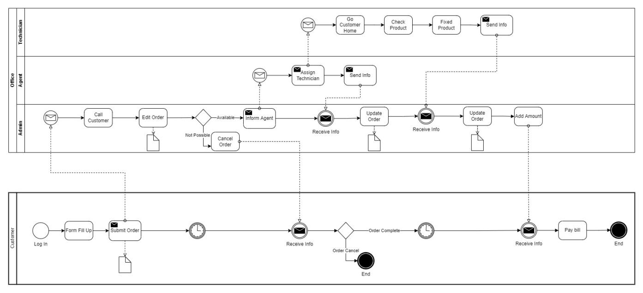

Figure 01: Business process model

Here a customer will login into the system then he/she will fill up a form for a repair request. Then this request will be reviewed by an admin. He will call the customer to get more details about the order. Then he will assign an agent for this task. An agent will select a technician for the task. The technician will go to the customer's home, review the product and try to fix that product. After completing the task admin will add cost to the customer account. And finally, the customer will pay their bills and close the process.

**3.2 Requirement Collection and Analysis**

**3.2.1 Functional Requirements**

**3.2.1.1 Admin requirements**

* Admin Login

This system to able to give permission to access the website to the admin and he can access the whole system.

* Database management

Admin controls the database and keeps track of all records of product and client details.

* Manage service

Admin can add, Update and delete any service category. He can also view, add, update and delete any service brand name and model number.

* View customer details

Admin views the personal details of the customer.

* Manage Agent

Admin can view all the agents who have contracts with the system. He can add, and update any agent's information.

* Manage Technician

Admin can view all the technicians who work for the system. He can add, and update any technician’s information.

* Manage Order

Admin can view and update any order. When a repair request is submitted into the system by a customer the admin can view that order. He can accept that order, assign a technician for that order and finally confirm the order by updating it.

* Logout

Admin can log out from the system.

**3.2.1.2 User requirements**

User Login:

Description of the feature

Using this feature users can log in to the system. A user should log in with his/her username and password to the system after registration. An invalid username or password is not allowed to enter the system. A user can also login into the system with a google account.

Functional requirement

A username and password will be provided after user registration is confirmed.

Password must be hidden from others while typing it in the field.

A google login button should be implemented to log in by Google

New user registration:

Description of the feature

A new user will have to register in the system by providing essential details in order to purchase products in the system.

Functional Requirement

The system should be able to verify and validate the information.

Password should be encrypted to provide security.

View and update own details:

Description of the feature

Customers can view/update their personal information. Customers can also set a default address.

Choose a service:

Description of the feature

Customers can view all the services that are provided by the system at that time. Customers can also see which brands are available and their model number for a product to repair.

Repair request:

Description of the feature

Customers can select any service, then fill up a form with the details of the product and select the cross-pounding brand and model number for the product to send a repair request. He can also remove any service request from the cart by clicking remove. He can track his request.

History:

Description of the feature

The customer can see all his previous service requests and their details.

Notification:

Description of the feature

The customer will get a notification on every step of the order.

Logout:

Description of the feature

The customer can log out of the system.

**3.2.2 Non-Functional Requirements**

**3.2.2.1 Performance requirements**

The system must accommodate a high number of items without any fault and view information could not take longer than 3 seconds to appear on the screen.

**3.2.2.2 Usability requirements**

The android app is designed for a user-friendly environment and is easy to use.

**3.2.2.3 Security**

Functions of the app must be accessed in the way they were intended to be accessed.

Included files shall not be accessed outside of their parent file.

Administrators can only perform the administrative task on pages they are privileged to access. The customer will not be allowed to access the administrator pages.

API should be accessed only by authorized users.

**3.2.2.4 Error-handling**

The app must handle its internal error and it should not terminate for an error. It should show the causes of the error to the users.

**3.2.2.5 Efficiency and Maintainability**

Page loads should be returned and formatted in a timely fashion depending on the request being made.

Administrators will have the ability to edit the aspect of order forms, service descriptions, prices, and websites directly.

The customer should send a repair request, track his order and get the notification of the order in an efficient manner.

**3.2.2.6 Reliability Requirement**

The system should provide a reliable environment to customers and owners. All orders must be reached at admin without any error.

**3.3 Use Case Diagram**

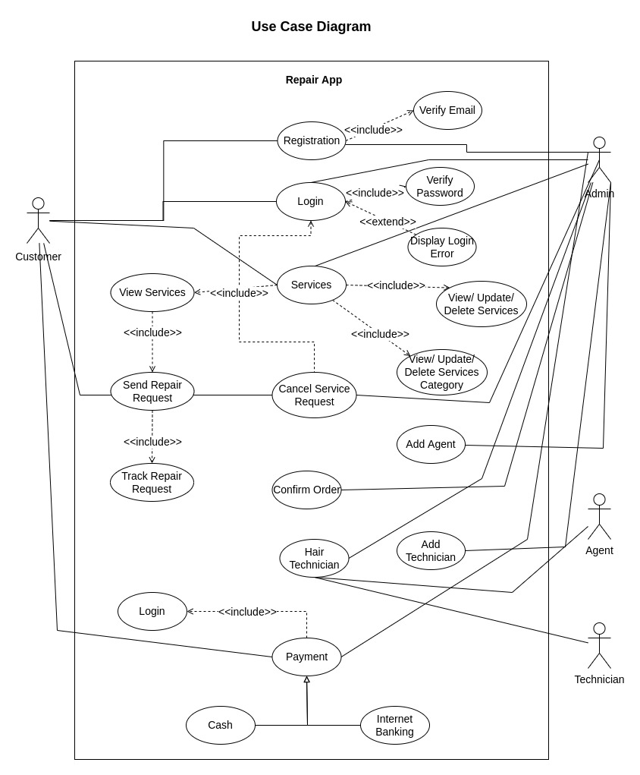

Figure 02: Use Case Diagram

**3.3.1 Use Case Description**

|  |  |
| --- | --- |
| **Use Case ID** | **UC1** |
| Name | Registration. |
| Description | This use case allows users to register into the system to access the relevant functions according to the user's role. The various user roles are customer and admin. To register to the system, all users have to enter their name, email, and password. Then a verification email will be sent to the user's email to verify their email address. They have to click the link provided in the email. After successfully verifying their registered users can now login into the system. |
| Actor | Admin  Customer |
| Pre-Condition | All the information Fields must be filled up. |
| Post-Condition | Users can login into the system. |
| Flow | Fill up the registration form with the necessary information.  Press the Sign Up button.  The system will verify the given information  The system will send a verification email to the user's email address  The user will click the link that is provided in the email  The system will verify the user account  Users can now login into the system |
| Include | Verified email address. |

Table 01: Use Case Diagram (Registration)

|  |  |
| --- | --- |
| **Use Case ID** | **UC2** |
| Name | Login. |
| Description | This use case allows users to login into the system to access the relevant functions according to the user's role. The various user roles are customer and admin. Users can log in to the system in two ways. By Email and password and by Google login. To log in by email and password, users have to verify their email address first. By providing the correct email and password or by the google login function user can successfully login into the system. They will receive a JWT token for the authorization and redirect to the home page. |
| Actor | Admin  Customer |
| Pre-Condition | All the information Fields must be filled up. |
| Post Condition | Get access to the system. |
| Flow | Go to the Login page  Enter your email address and password.  Google login  Press the Login button.  The system will verify the account.  The system will send a JWT token for authorization and redirect to the home page  Otherwise, display a Login error. |
| Include | Verify password. |

Table 02: Use Case Diagram (Login)

|  |  |
| --- | --- |
| **Use Case ID** | **UC3** |
| Name | Service. |
| Description | In this use case, the admin can add, delete and update any service. They can also add, delete and update any product brand and product model. Customers will browse all the available services. They can send select any services and send a repair request to the server. To send a repair request they have to fill up a form and then select the product brand and a product model. After submitting the repair request admin will take further action. |
| Actor | Admin  Customer |
| Post Condition | Hire technicians based on their product requirements. |
| Flow | Go to the service section.  Select product brand and product model  Fill up the request form  Send service request  Track the repair request  Admin will receive this repair request  Admin can add, delete or update any service  Admin can add, delete or update product brand and product model |
| Include | View Service  View, Update or Delete Services  View, Update or Delete Services brand and service model |

Table 03: Use Case Diagram (Service)

|  |  |
| --- | --- |
| **Use Case ID** | **UC4** |
| Name | Cancel Request. |
| Description | The customer is not interested anymore in the service or the required service isn’t available on the system. |
| Actor | Admin  Customer |
| Post Condition | Cancel Service Requests in order to reinforce the user’s requirement. |
| Flow | View the order list.  Select the specific booking.  Give a reason and Press the Cancel Request button. |
| Include | Login. |

Table 04: Use Case Diagram (Cancel Request)

|  |  |
| --- | --- |
| **Use Case ID** | **UC5** |
| Name | Confirm Order. |
| Description | Admin checks all the necessaries and confirms the Order. |
| Actor | Admin |
| Post Condition | The administrator agent allows the Customer for the asking service. |
| Flow | View request details from the system database.  Verify request.  Confirm request. |
| Include | None |

Table 05: Use Case Diagram (Confirm Order)

|  |  |
| --- | --- |
| **Use Case ID** | **UC6** |
| Name | Hair Technician. |
| Description | Admin will select an agent that is close to the order request address. Then admin will assign a technician for the job. The system will notify this state by a notification to the user app. |
| Actor | Admin  Agent  Technician |
| Post Condition | Technician will arrive for the service. |
| Flow | Check confirmation.  Select an agent  Select a technician close to the location  Notify the current stage by a notification to user |
| Include | None |

Table 06: Use Case Diagram (Hair Technician)

|  |  |
| --- | --- |
| **Use Case ID** | **UC7** |
| Name | Payment. |
| Description | After successfully repairing the product, the customer will select the payment option. They can make payments either cash on delivery or by internet banking. After a successful payment, this process will end. |
| Actor | Admin  Customer |
| Pre-Condition | Customer Get the expected servicing solution. |
| Flow | View the service tracker to get the amount total.  Choose a payment method.  For instant payment select cash.  For digital payment select internet banking.  Add this service to the History section. |
| Include | Login |

Table 07: Use Case Diagram (Payment)

|  |  |
| --- | --- |
| **Use Case ID** | **UC8** |
| Name | Add Agent. |
| Description | This use case allows the admin to add, view, and update an agent. To add an agent, they have to fill up a form with the necessary information and then click the add button to save the agent. |
| Actor | Admin |
| Pre-Condition | Fill up the form with the necessary information |
| Flow | Click the add button  Fill up the form  Submit the information. |
| Include | None |

Table 08: Use Case Diagram (Add Agent)

|  |  |
| --- | --- |
| **Use Case ID** | **UC9** |
| Name | Add Technician. |
| Description | This use case allows the admin to add, view, and update a technician. To add a technician, they have to fill up a form with the necessary information and then click the add button to save the technician. |
| Actor | Admin |
| Pre-Condition | Fill up the form with the necessary information |
| Flow | Click the add button  Fill up the form  Submit the information. |
| Include | None |

Table 10: Use Case Diagram (Add Technician)

**3.4 Activity Diagram**

An activity diagram is used to understand the flow of work that an object or component performs. It can also be used to visualize the interaction between different use cases.

**3.4.1 System Admin Activity Diagram**

Admin manage system content by creating, updating, or deleting content from the system database as well manage customers, orders, bookings, and payments in the system.

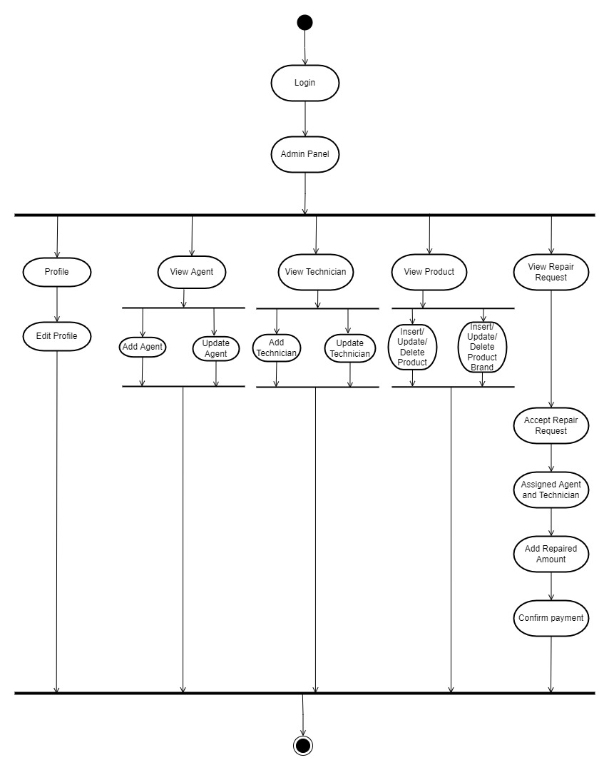

Figure 03: Admin Activity Diagram

**3.4.2 Customer Activity Diagram**

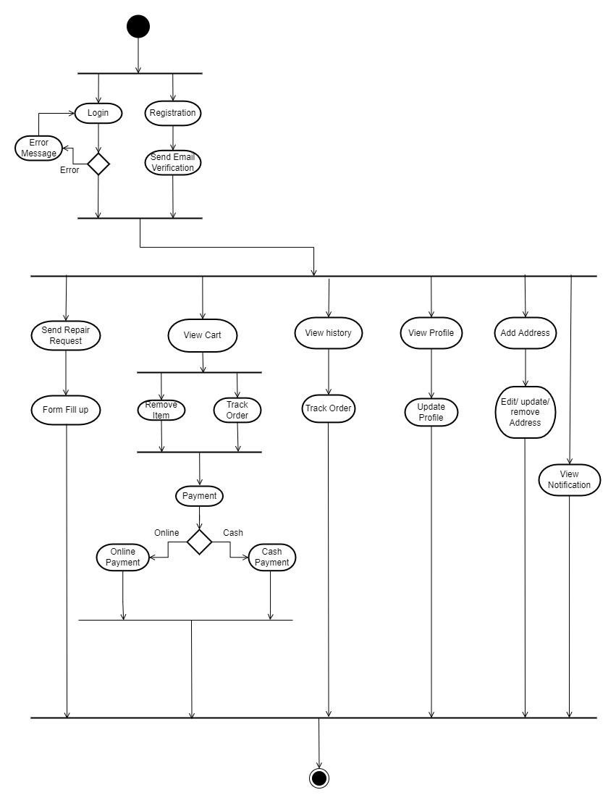

Figure 04: Customer Activity Diagram

**3.5 Sequence Diagram**

A Sequence diagram shows the sequence of messages exchanged by the set of objects performing a certain task.

**3.5.1 Admin Registration**

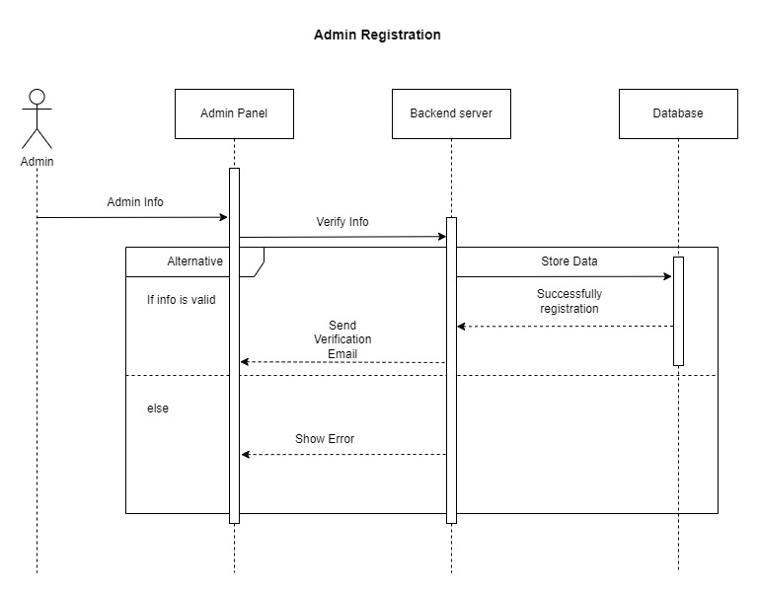

Figure 05: Admin Registration Sequence Diagram

**3.5.2 Admin Login**

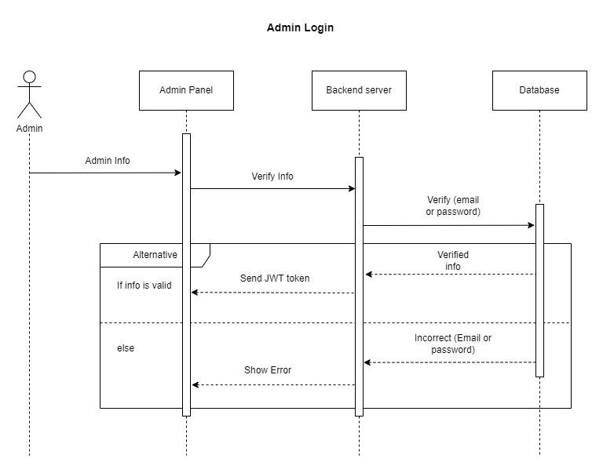

Figure 06: Admin Login Sequence Diagram

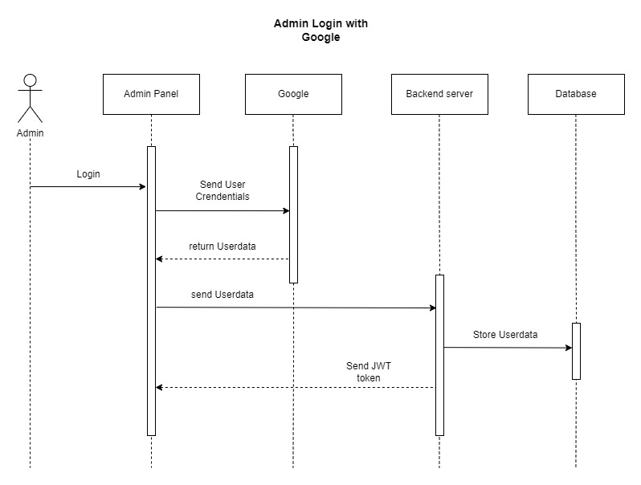

Figure 07: Admin Login with Google Sequence Diagram

**3.5.3 Admin Profile**

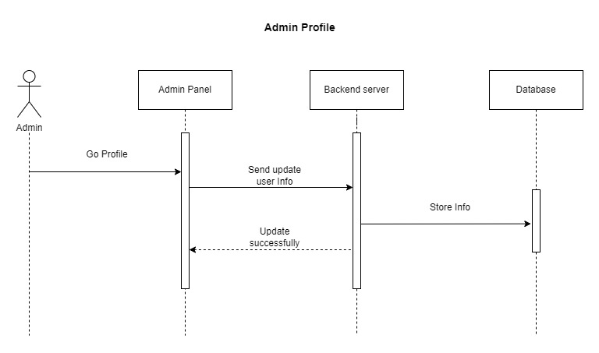

Figure 08: Admin Profile Sequence Diagram

**3.5.4 Admin Forget Password**

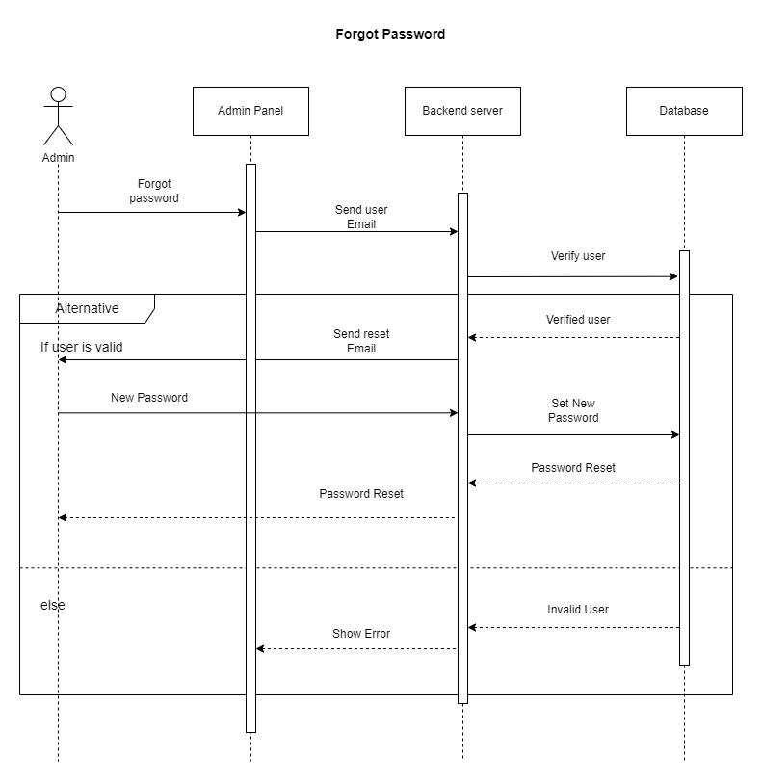

Figure 09: Admin Forget Password Sequence Diagram

**3.5.5 Admin View Order**

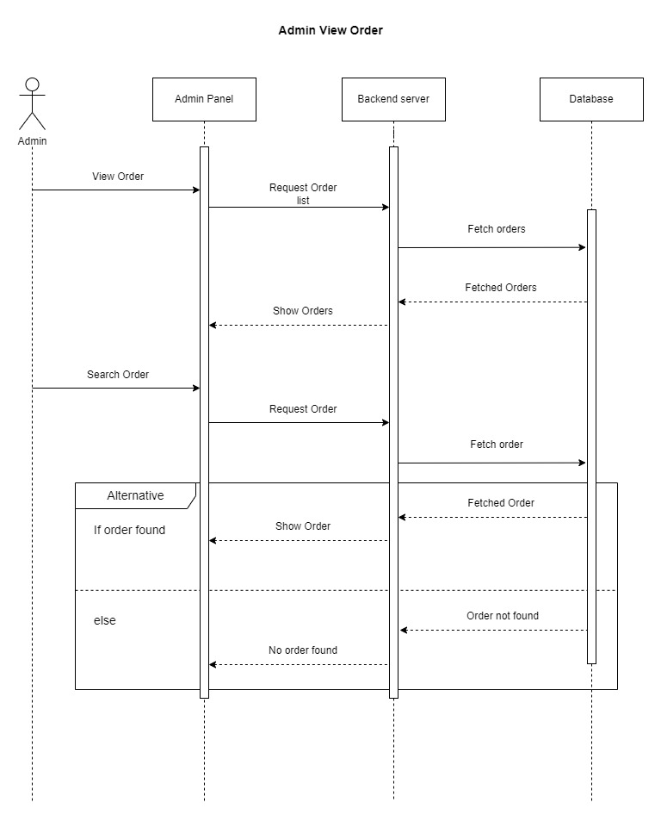

Figure 10: Admin View Order Sequence Diagram

**3.5.6 Admin Add Agent**

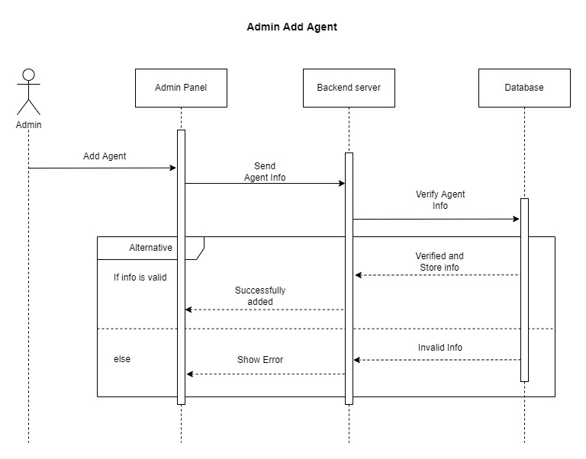

Figure 11: Admin Add Agent Sequence Diagram

**3.5.7 Admin Add Technician**

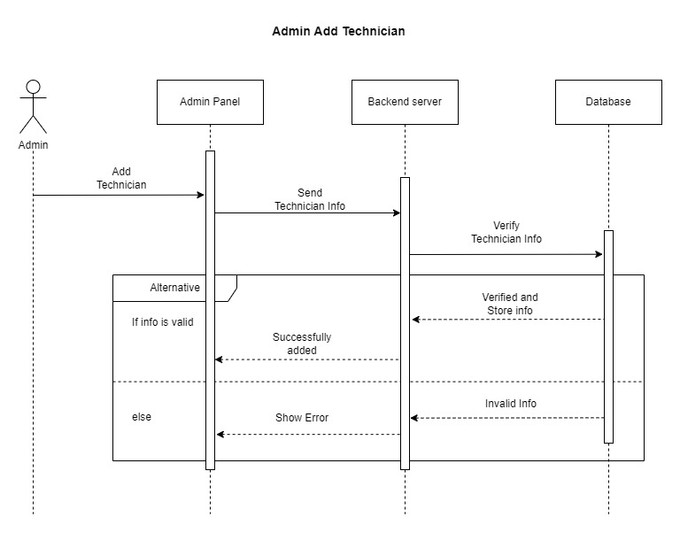

Figure 12: Admin Add Technician Sequence Diagram

**3.5.8 Admin Update Order**

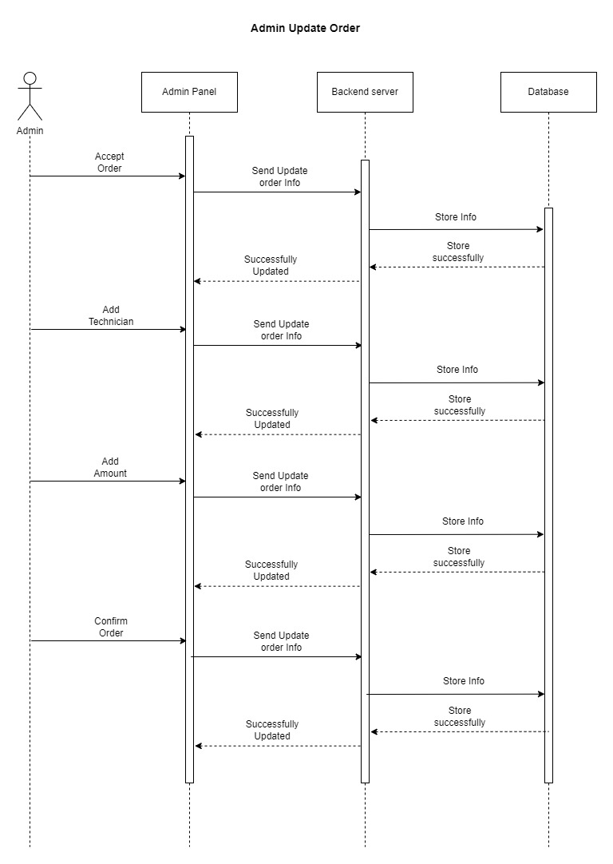

Figure 13: Admin Update Order Sequence Diagram

**3.5.9 Admin Update Agent**

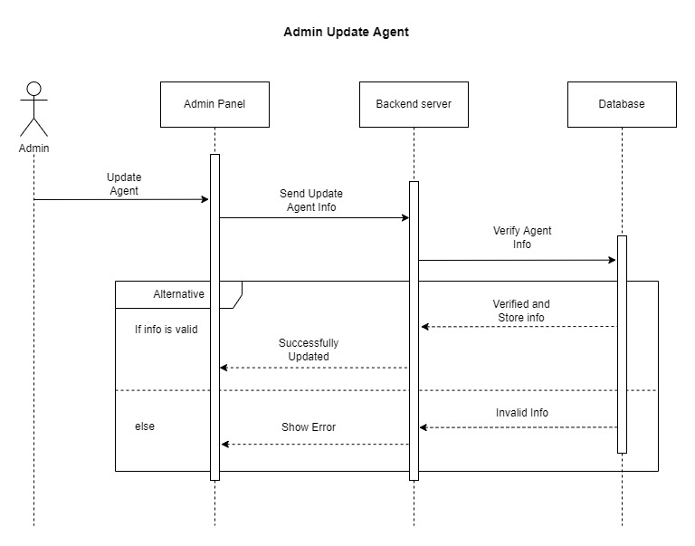

Figure 14: Admin Update Agent Sequence Diagram

**3.5.10 Admin Update Technician**

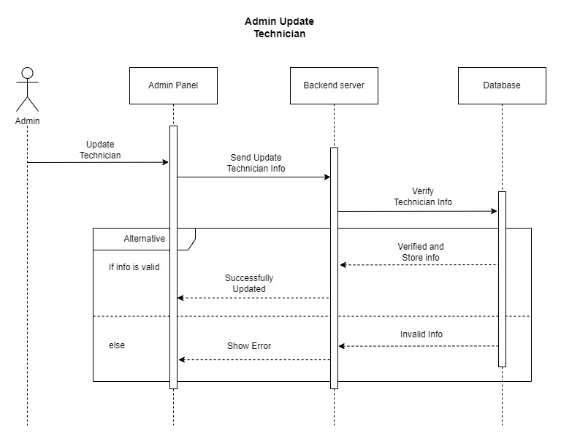

Figure 15: Admin Update Technician Sequence Diagram

**3.5.11 Customer Registration**

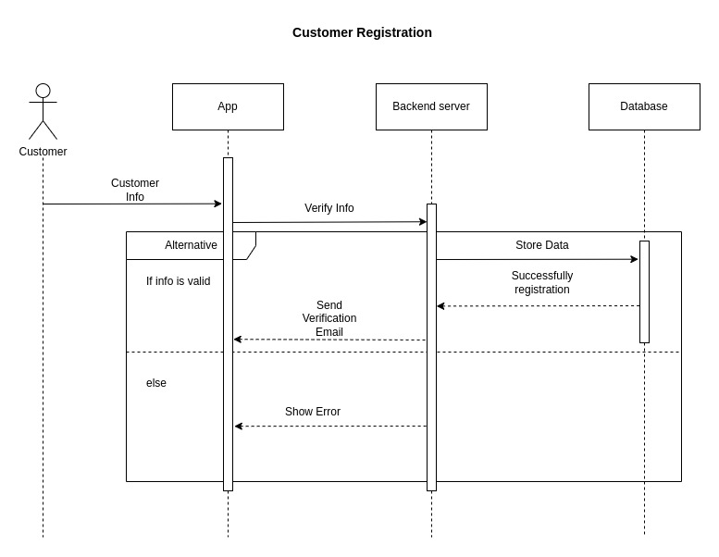

Figure 16: Customer Registration Sequence Diagram

**3.5.12 Customer Login**

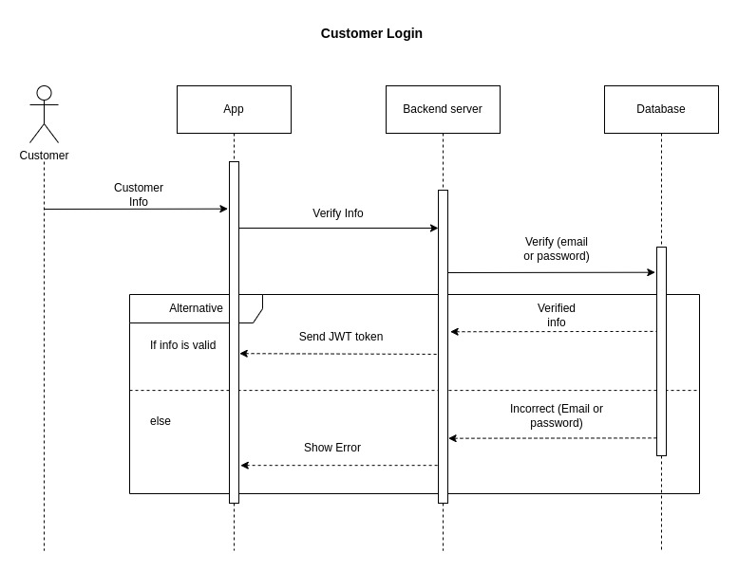

Figure 17: Customer Login Sequence Diagram

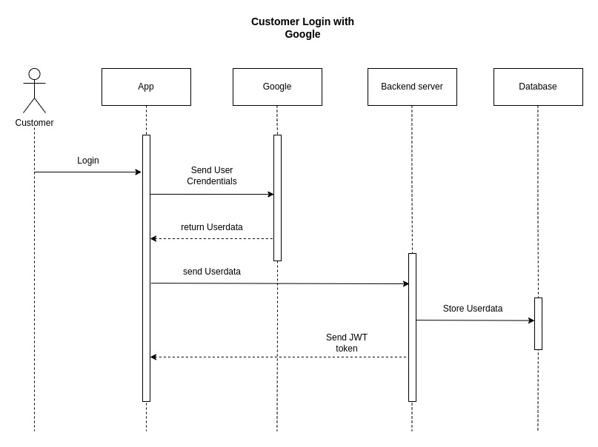

Figure 18: Customer Login with Google Sequence Diagram

**3.5.13 Customer Profile**

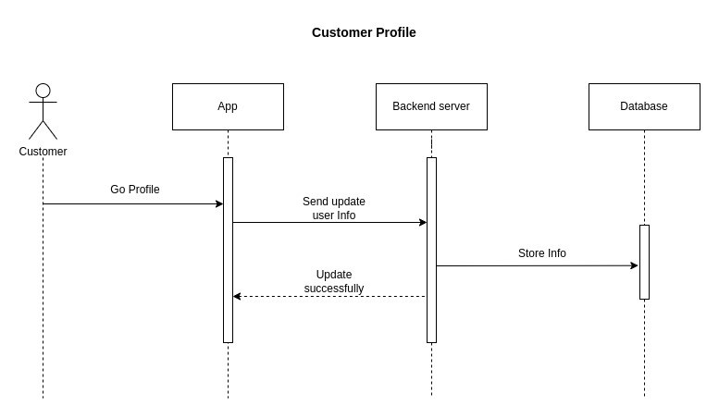

Figure 19: Customer Profile Sequence Diagram

**3.5.14 Forget Password**

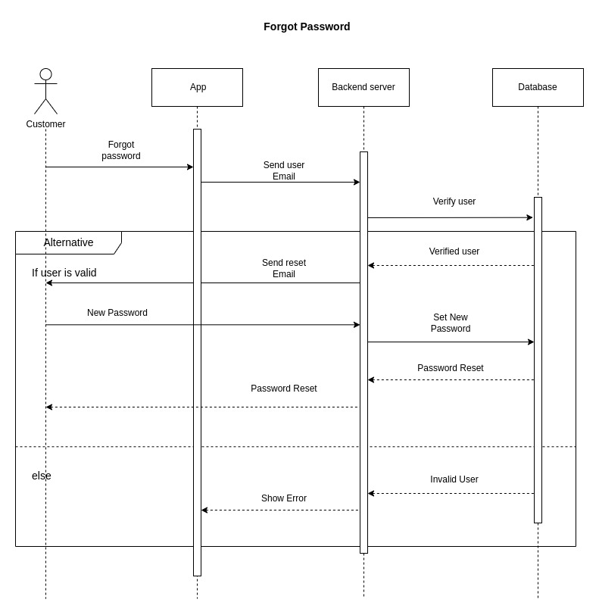

Figure 20: Customer Forget Password Sequence Diagram

**3.5.15 Customer Add Order**

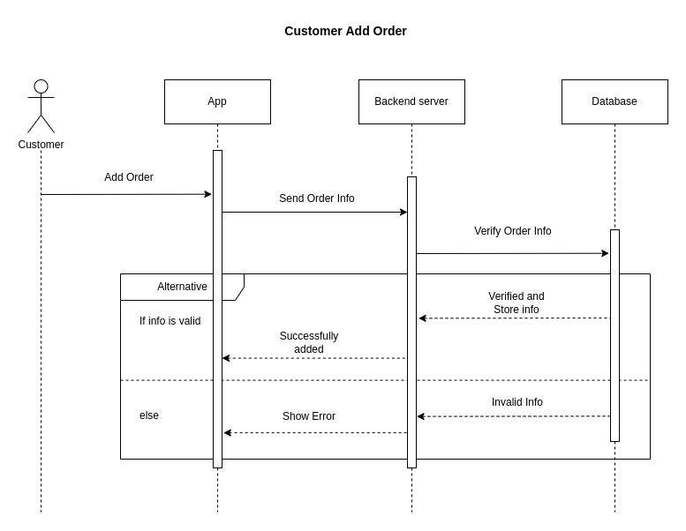

Figure 21: Customer Add Order Sequence Diagram

**3.5.16 Customer Add Address**

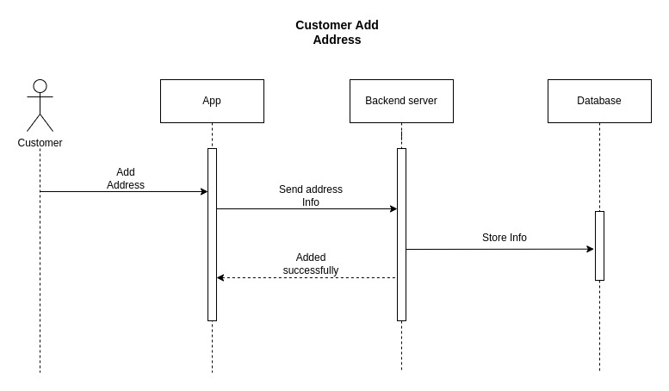

Figure 22: Customer Add Address Sequence Diagram

**3.5.17 Customer Update Address**

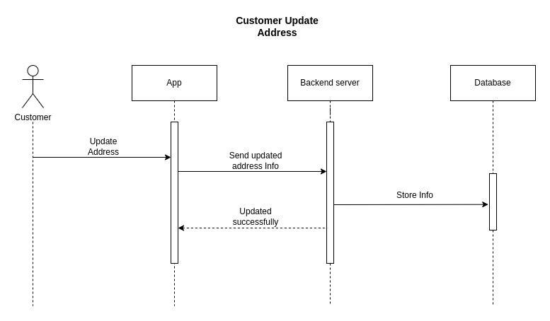

Figure 23: Customer Update Address Sequence Diagram

**3.5.18 Cart List**

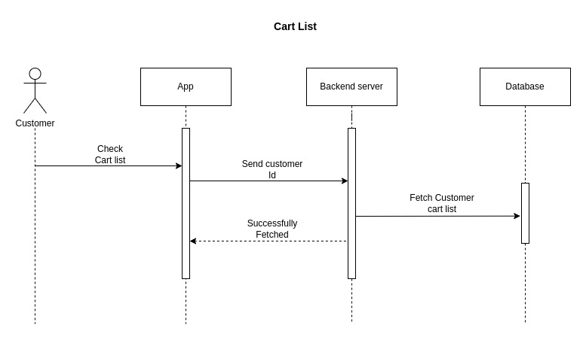

Figure 24: Cart List Sequence Diagram

**3.5.19 Track Order**

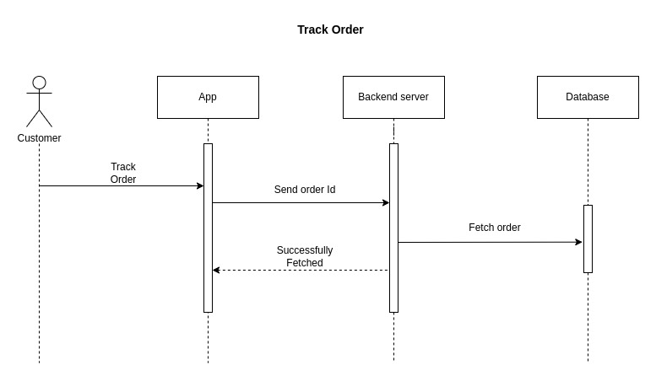

Figure 25: Track Order Sequence Diagram

**3.5.20 Order History**

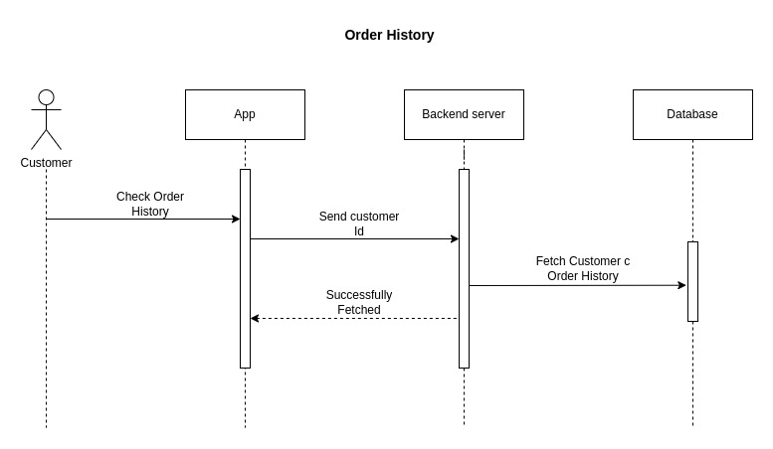

Figure 26: Order History Sequence Diagram

**3.5.21 Payment**

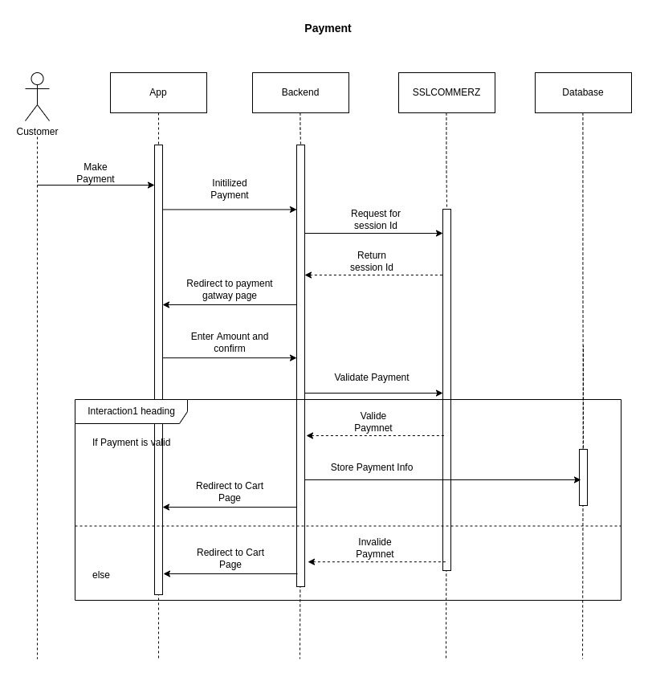

Figure 27: Payment Sequence Diagram

**3.6 Design Requirement**

We research and analyze so many designs for making an attractive design for our project. We have three parts to our project. First the android app, second the admin panel for controlling the system, and third the back-end application. For the android app, we will use React Native to make a cross-platform android app. For the admin panel, we will use HTML5, CSS3, Bootstrap, and React JS and for the back-end application, we will use NodeJS and MongoDB database.

A design must need to be,

Simple

Responsive

Easy to access

Different user can access

**CHAPTER 4**

**DESIGN SPECIFICATION**

**4.1 Front End Design**

**4.1.1 Android App**

Welcome Screen

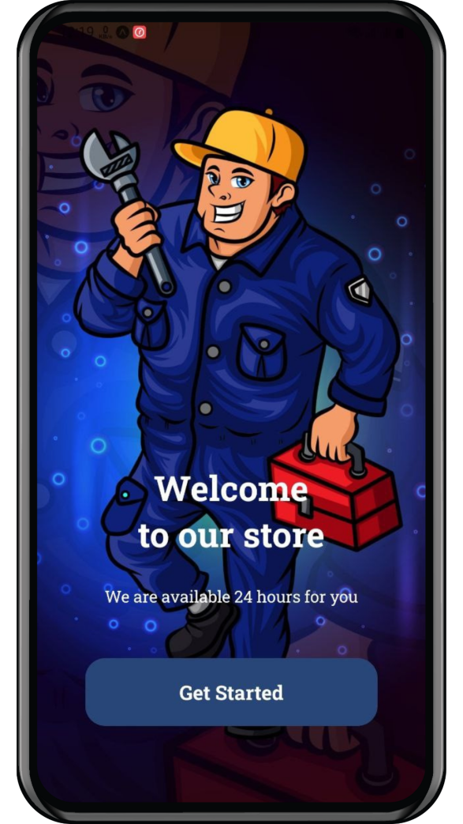

Figure 28: Welcome Page

**Login Page**

Users can log in to the system in two ways. They can use email and password for their login or they can use a Google account for login. If anyone forgot their password then there is a forgot password button that will send a reset email to the email address to reset the password.

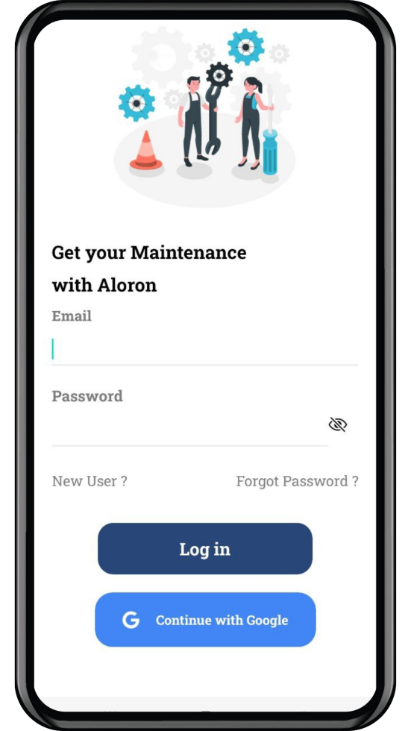 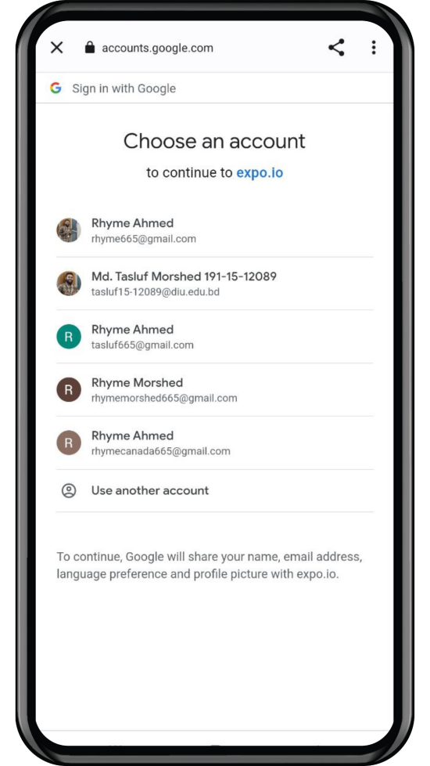

Figure 29: Login Page

**Sign Up Page**

Back-end authenticates sign-up need to enter in this application. Required information (1) Name, (2) Email, (3) Password (4) Confirm Password then the user should Click on the “Sign Up” button. Then the user gets a verification email with a verification link. If the user clicks that link back-end will automatically verify the user account and allow that user to log in.

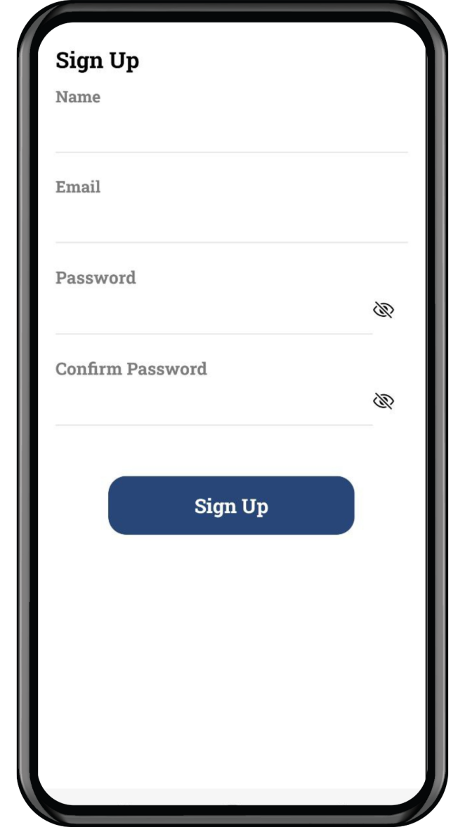

Figure 30: Sign Up Page

**Home Page**

After successful login in or sign-up, the user will redirect to the home page.

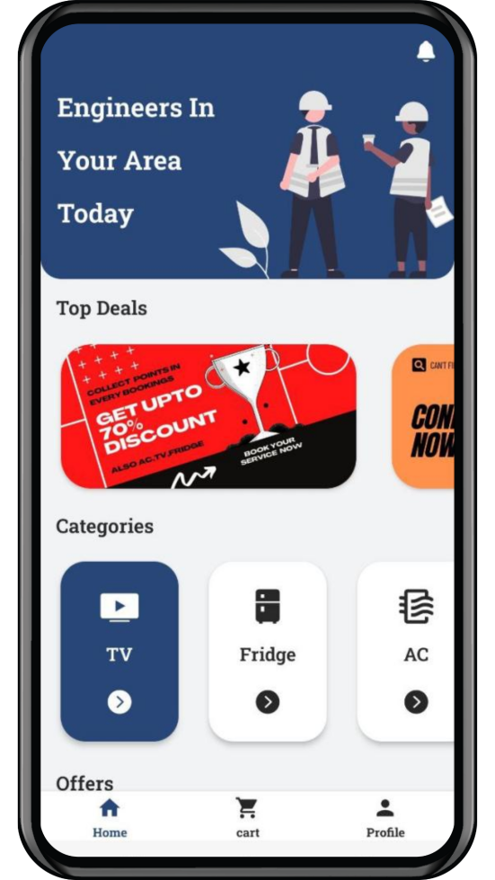 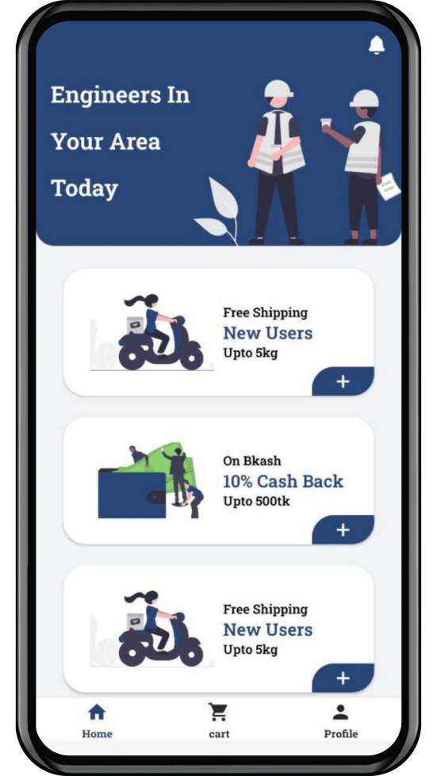

Figure 31: Home Page

**Order Page**

By submitting a form users can hire technicians to repair their products. They have to fill up some information and book an order.

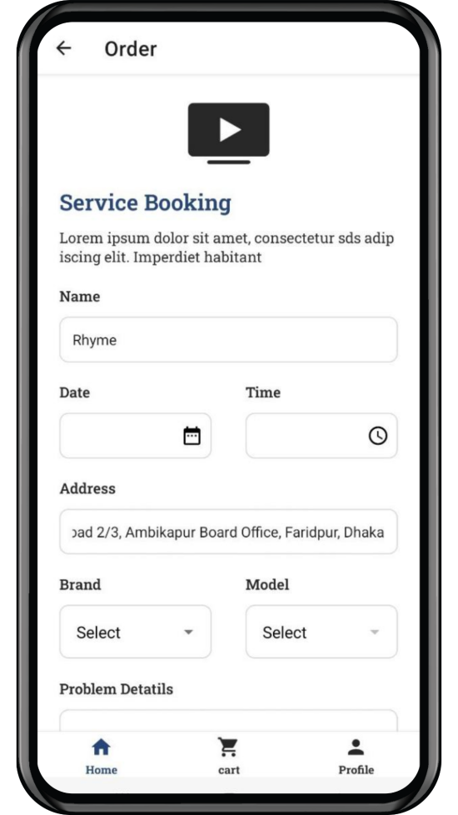 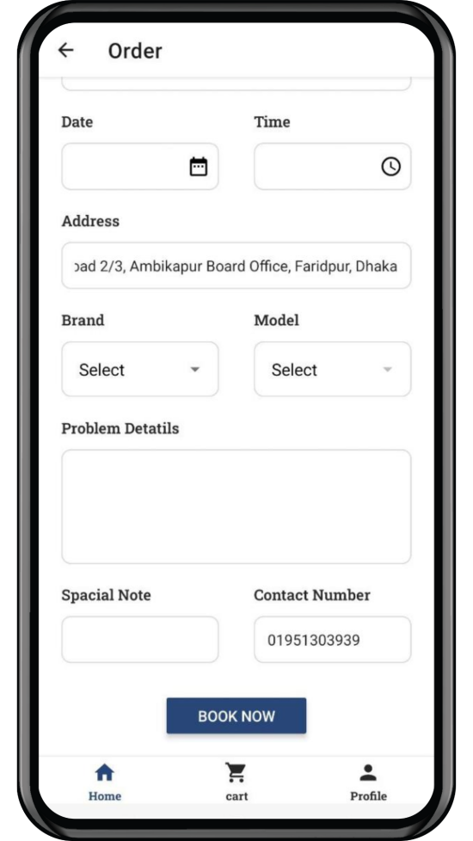

Figure 32: Order Page

**My Cart Page**

After submitting an order users can track their order on the My cart page. And after repairing the product user will be able to pay their bills.

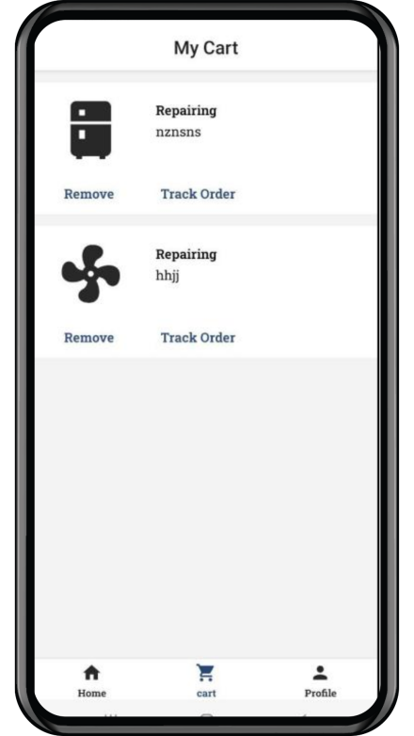 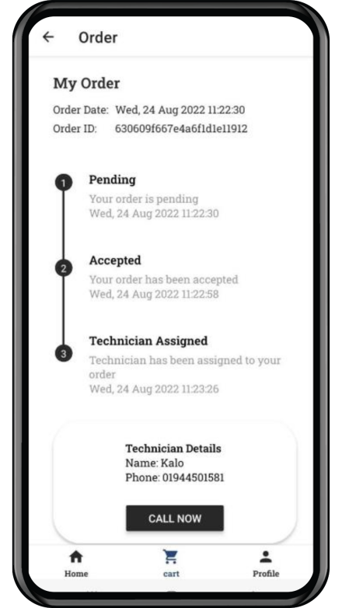 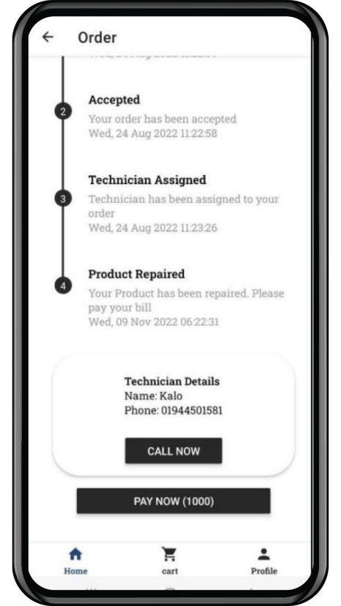

Figure 33: My Cart Page

**Payment Page**

Users are able to pay their bills by sslcommerz payment gateway. With this getaway, they can use any kind of internet banking system like Bkash, Nagad, Rocket, etc. They can also use Visa and Master Card for payment.

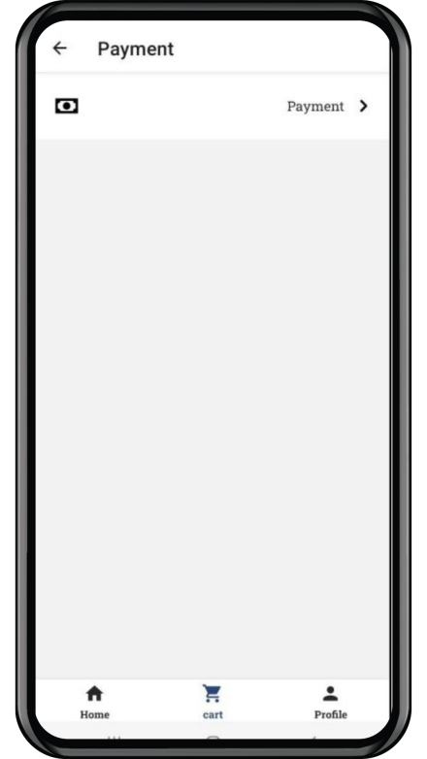 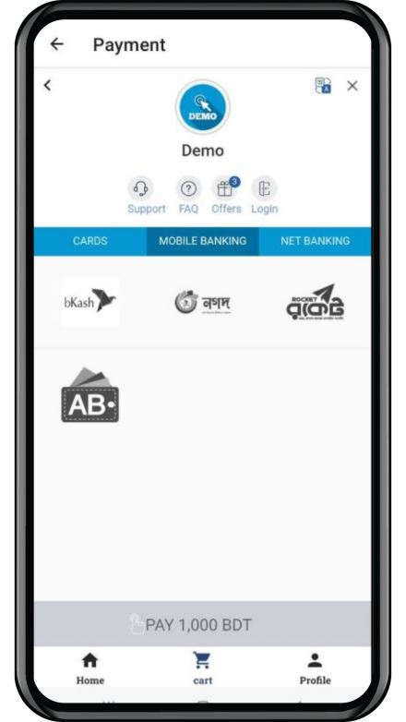 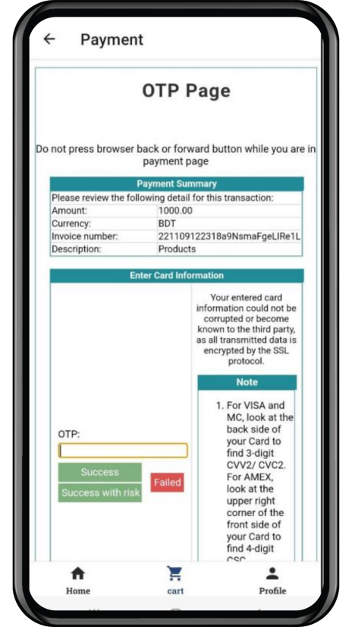

Figure 34: Payment Page

**Profile Page**

User will see their profile and other information on this page. They can change their profile picture. If the user press How can we help you? then it will make a phone call to customer care.

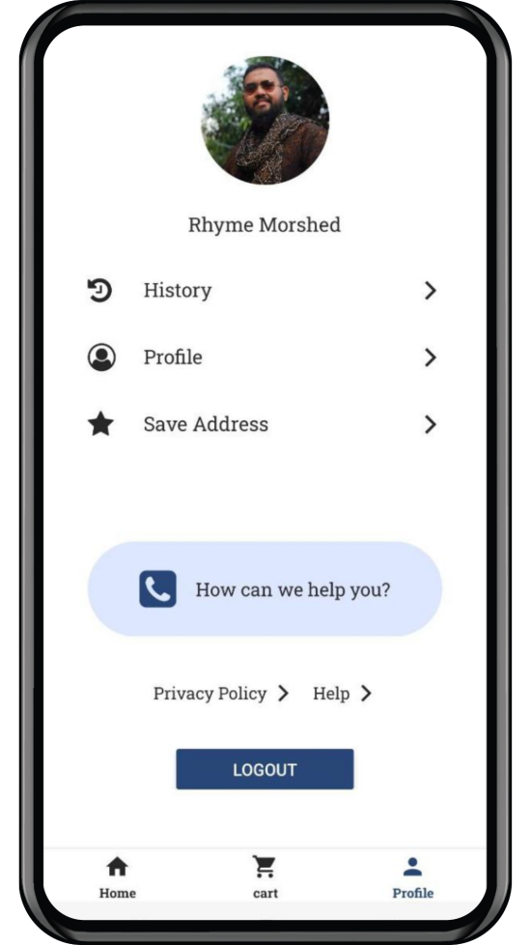 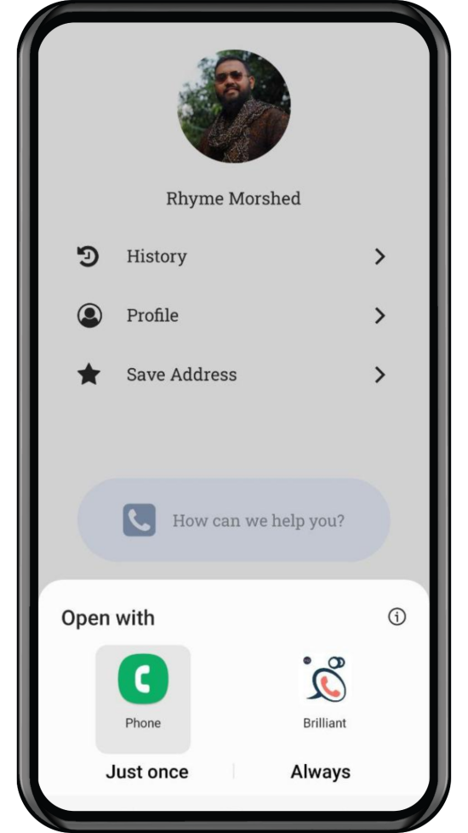

Figure 35: Profile Page

**History Page**

After repair, the product users order will be listed on the history page. Here user can see all his/her previous order details.

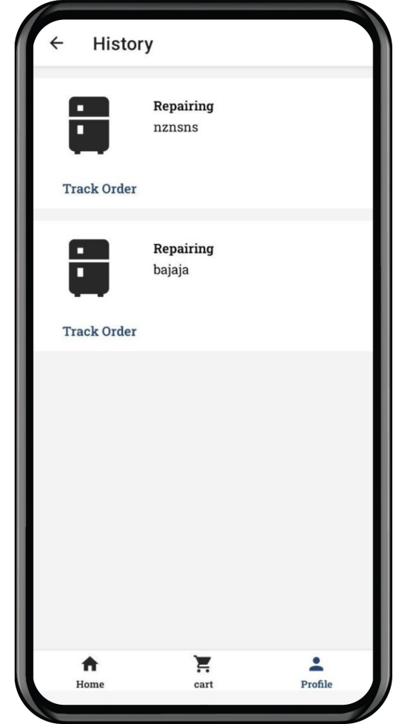 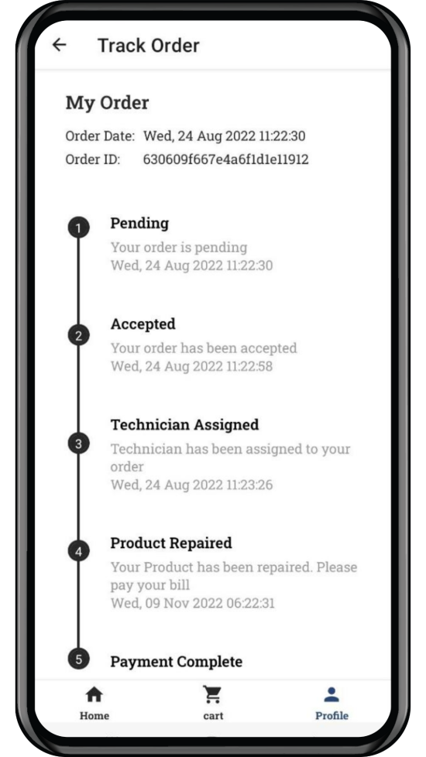

Figure 36: History Page

**Profile Edit Page**

Here user can update their profile. They can edit their name. Add phone number, select gender and select birthday.

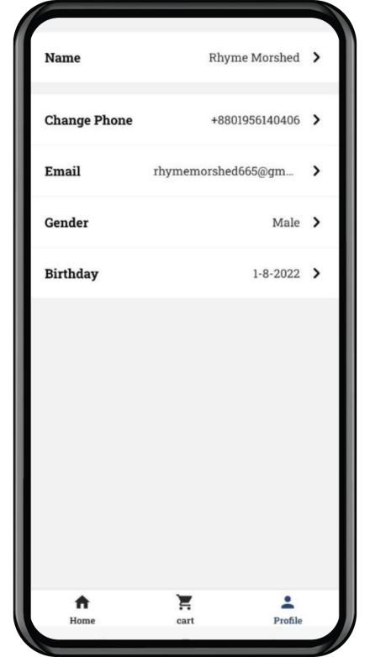 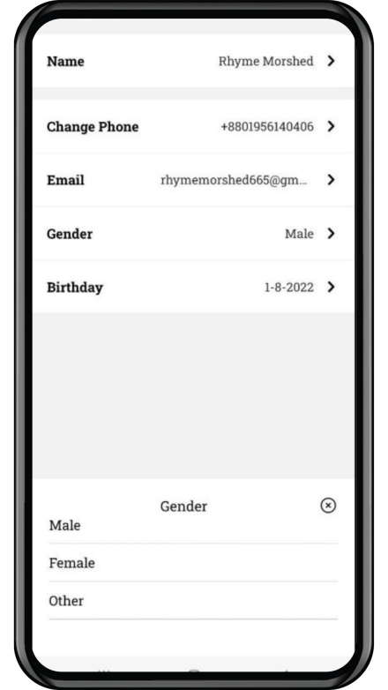 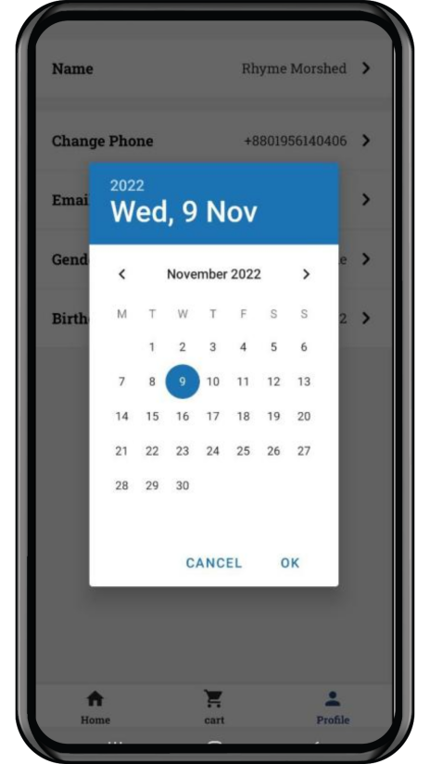

Figure 37: Profile Edit Page

**Address Page**

User can add their home and office address. Update and delete the current address.

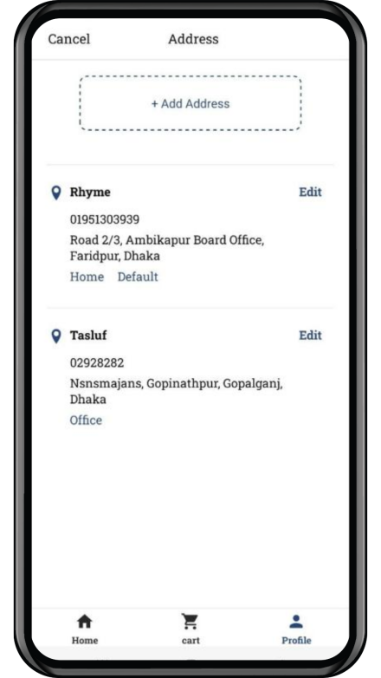 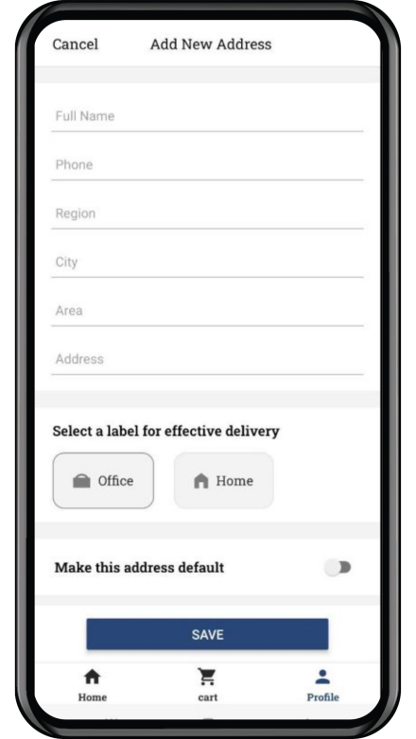 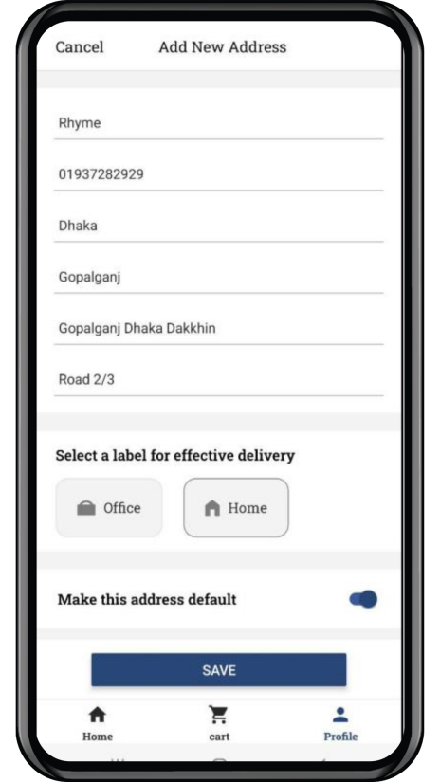

Figure 38: Address Page

**Select Address Page**

Users can select the Region, City, and area of their address

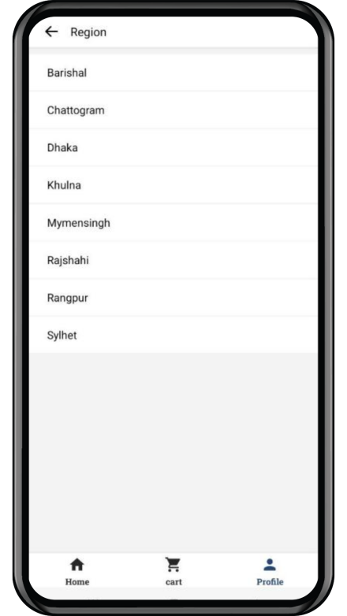 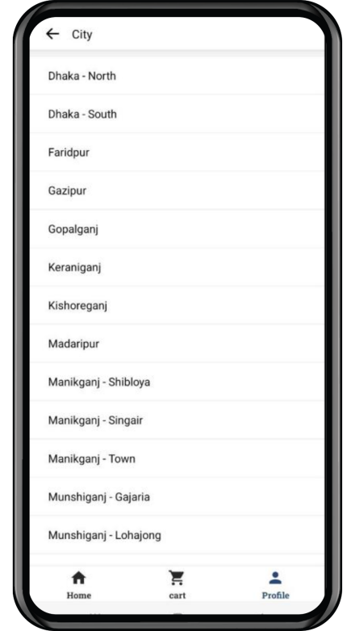 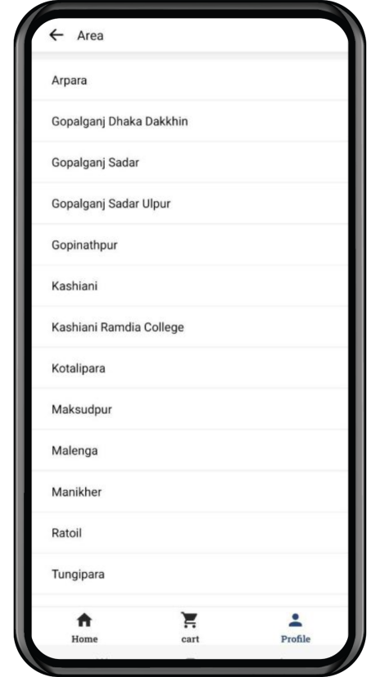

Figure 38: Select Address Page

**Notification Page**

All the notifications of the app will be shown on this page.

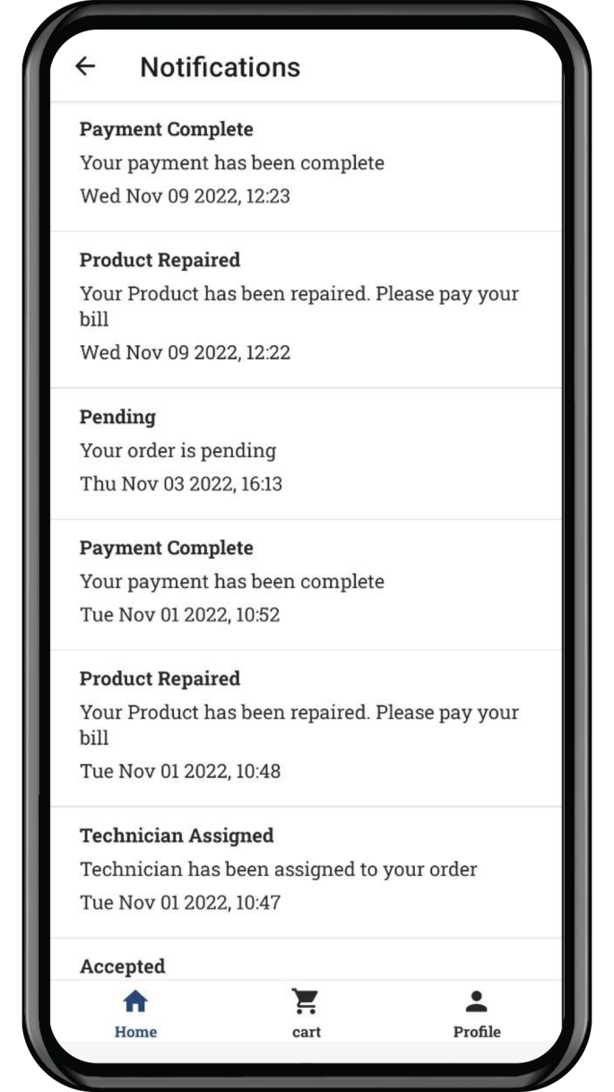

Figure 39: Notification Page

**4.1.2 Admin Panel**

**Login Page**

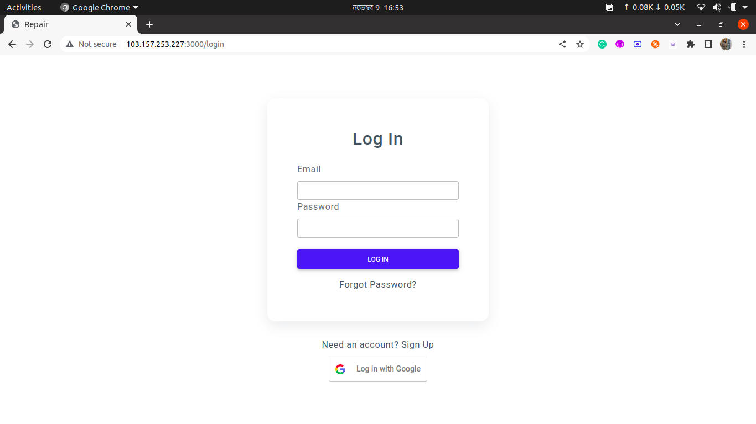

Figure 40: Login Page

**Sign Up Page**

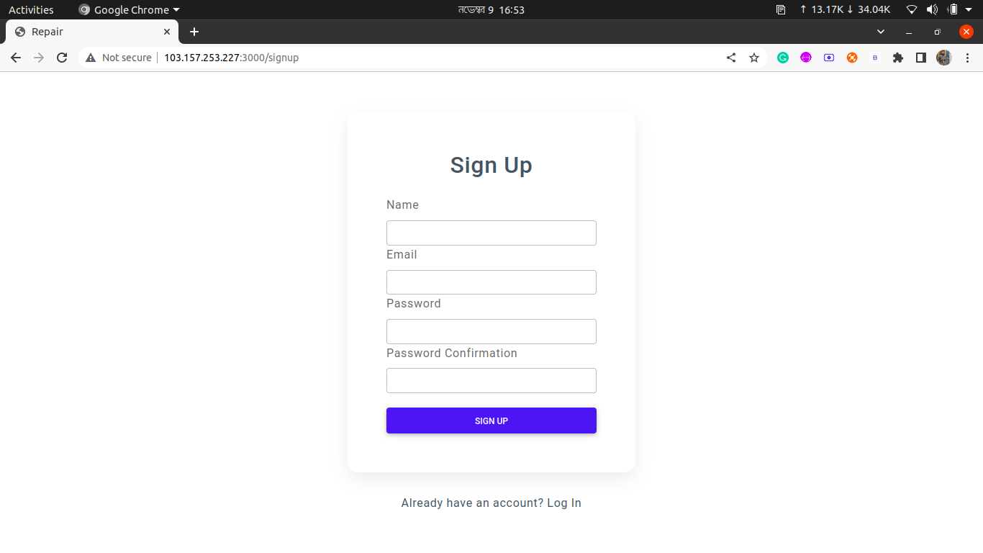

Figure 41: Sign Up Page

**Forgot Password Page**

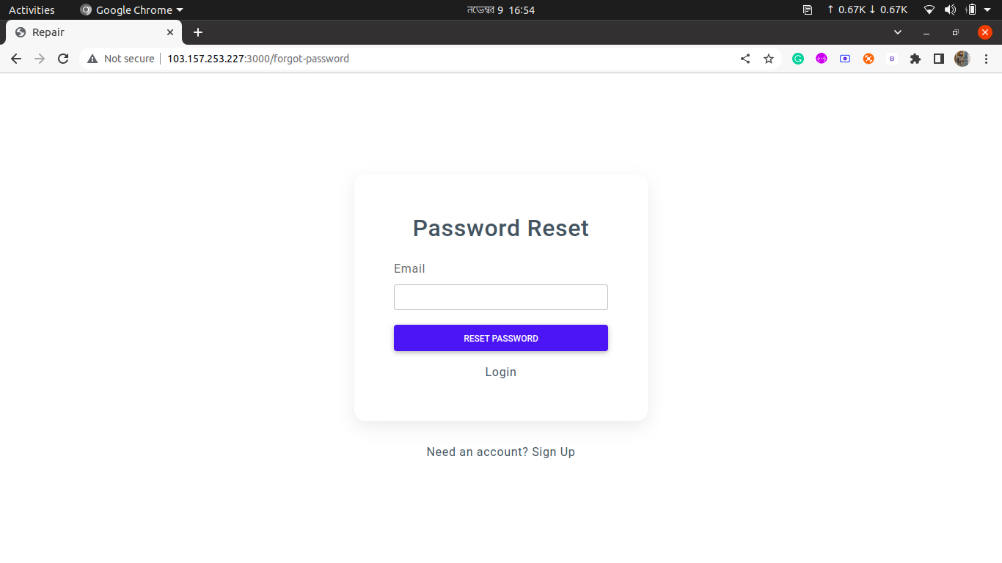

Figure 42: Forgot Password Page

**Dashboard Page**

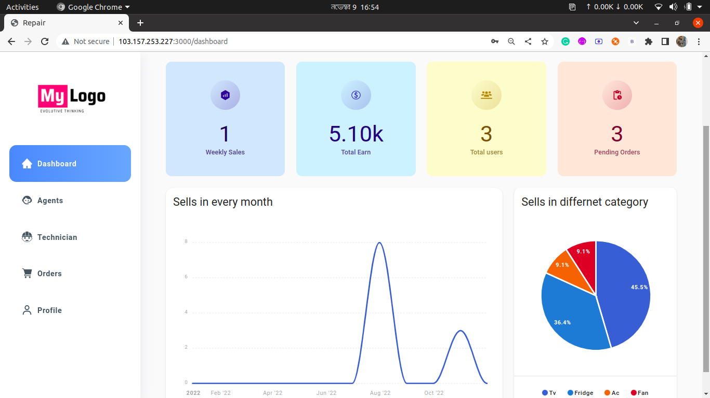

Figure 43: Dashboard Page

**Agent Page**

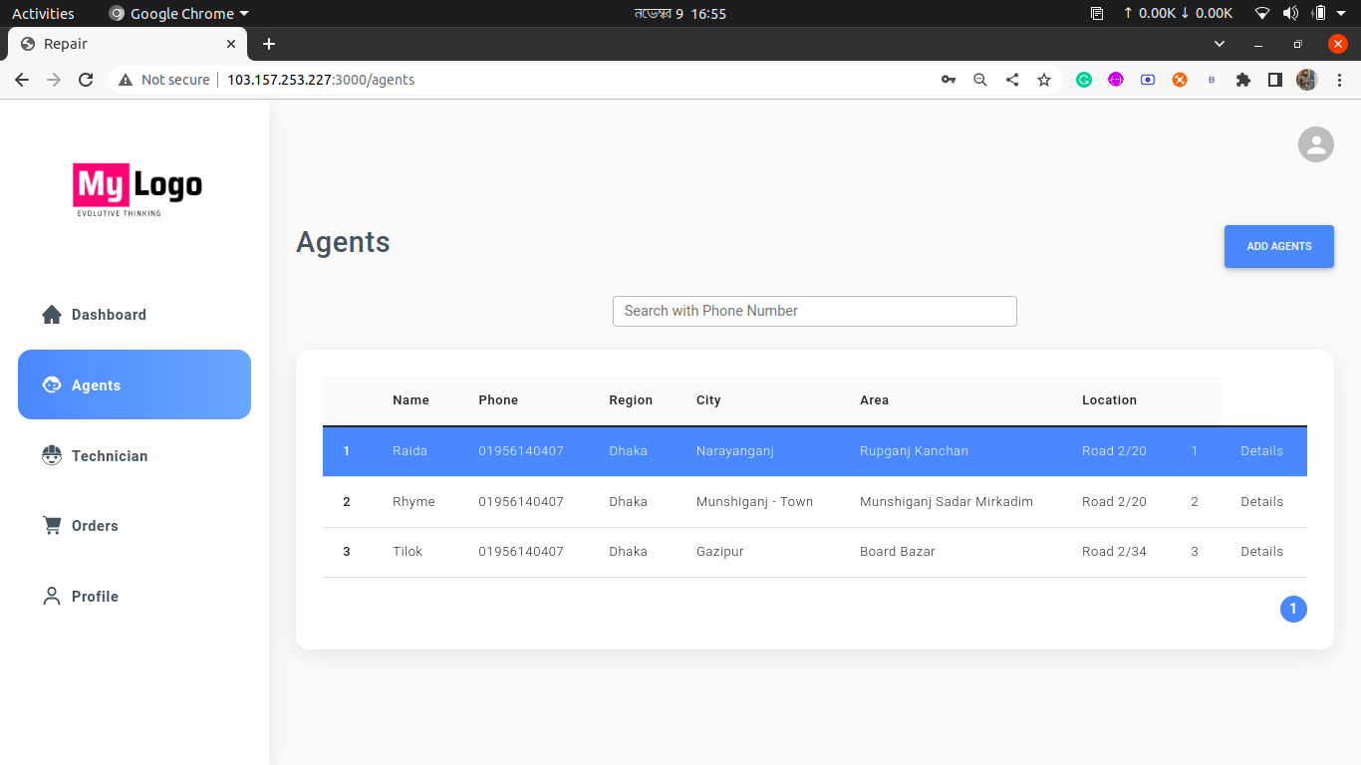

Figure 44: Agent Page

**Add Agent Page**

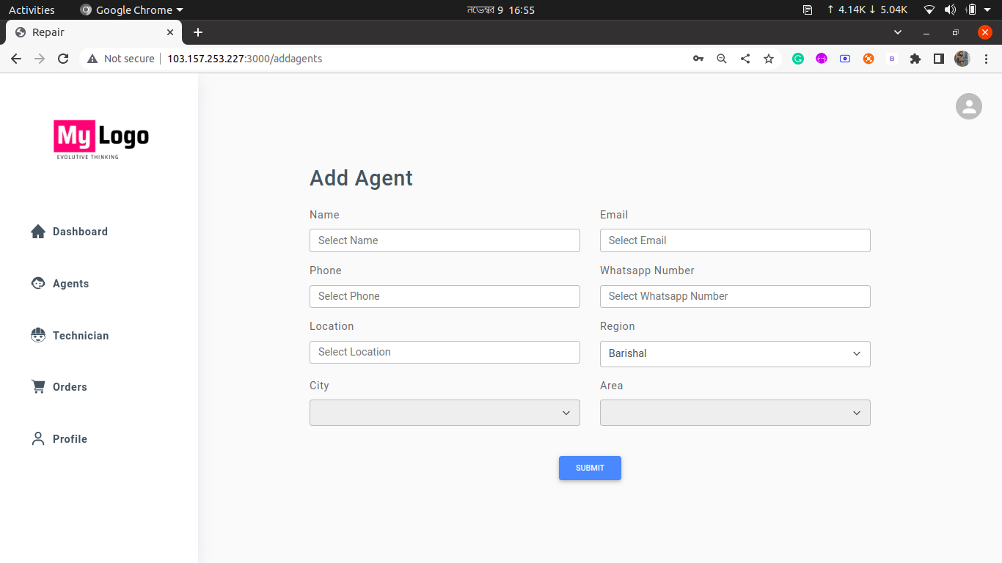

Figure 45: Add Agent Page

**Update Agent Page**

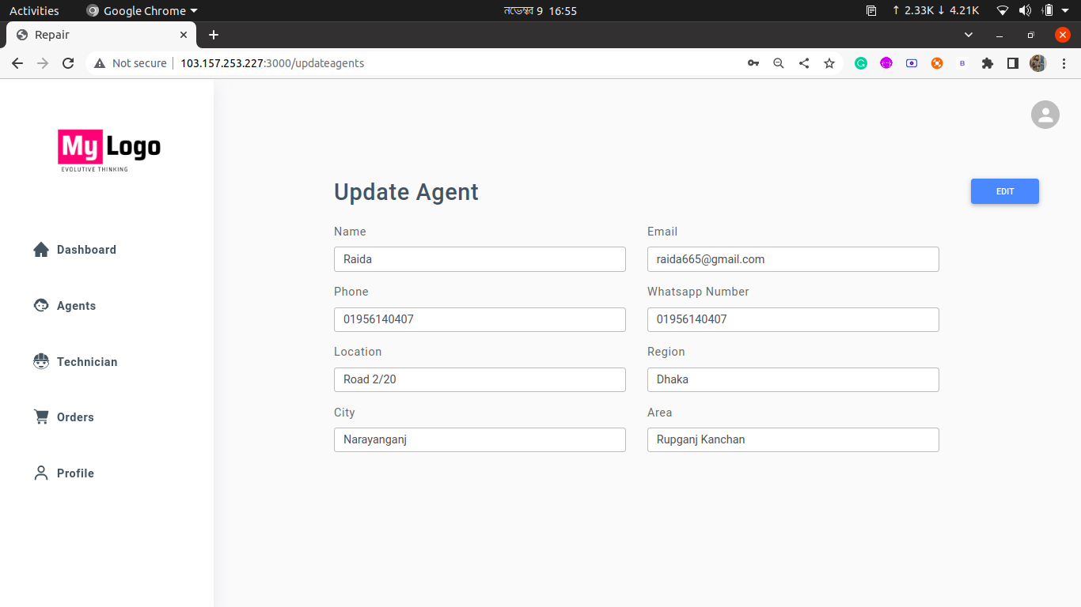

Figure 46: Update Agent Page

**Technician Page**

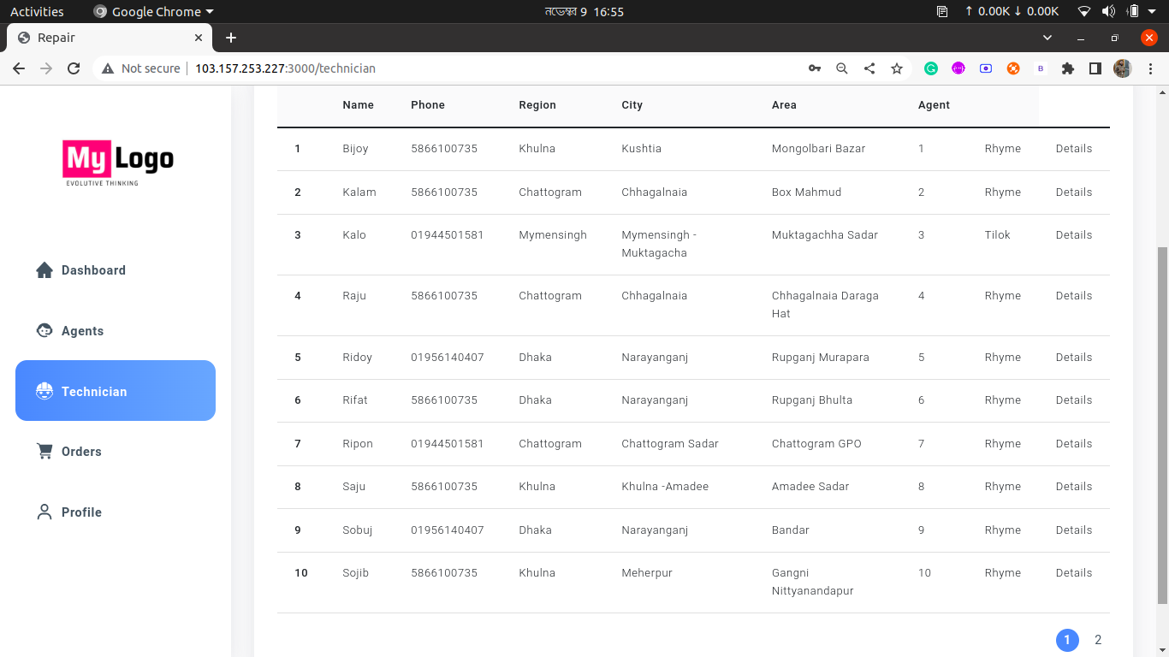

Figure 47: Technician Page

**Add Technician Page**

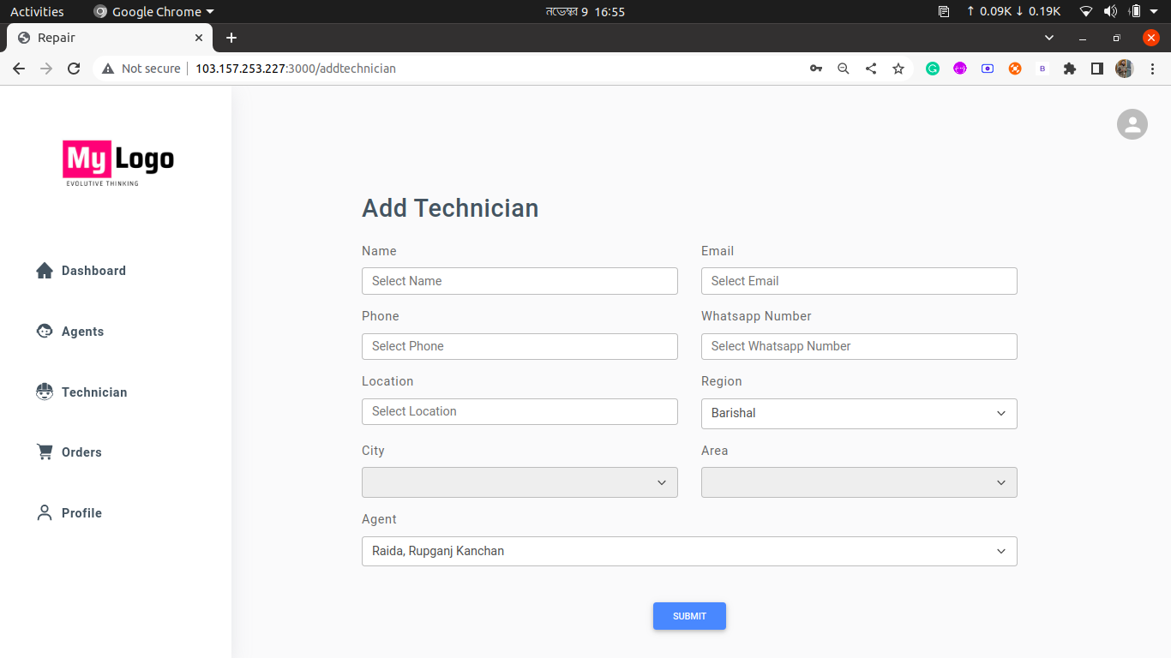

Figure 48: Add Technician Page

**Order Page**

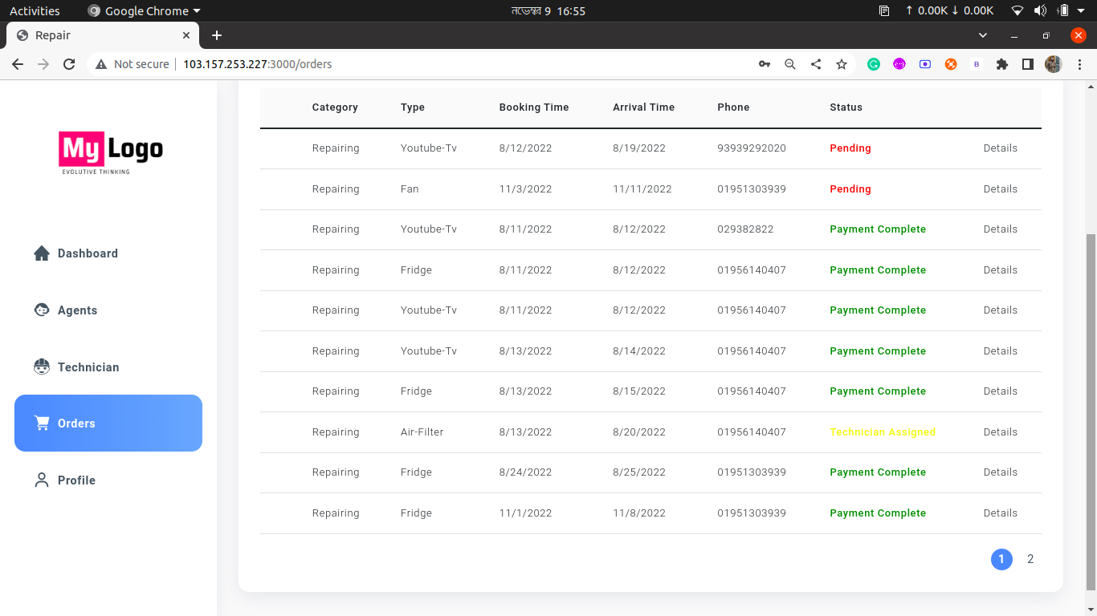

Figure 49: Order Page

**Order Details Page**

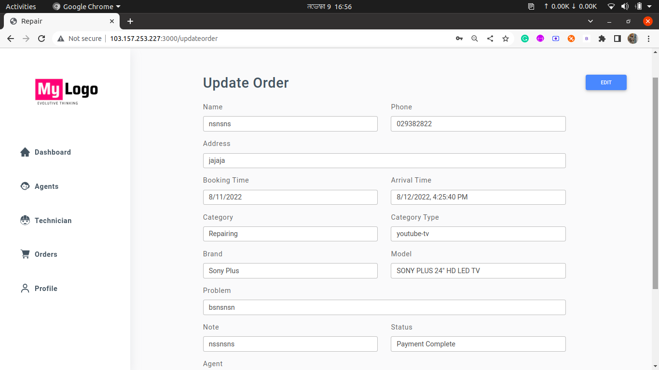

Figure 50: Order Details Page

**Profile Page**

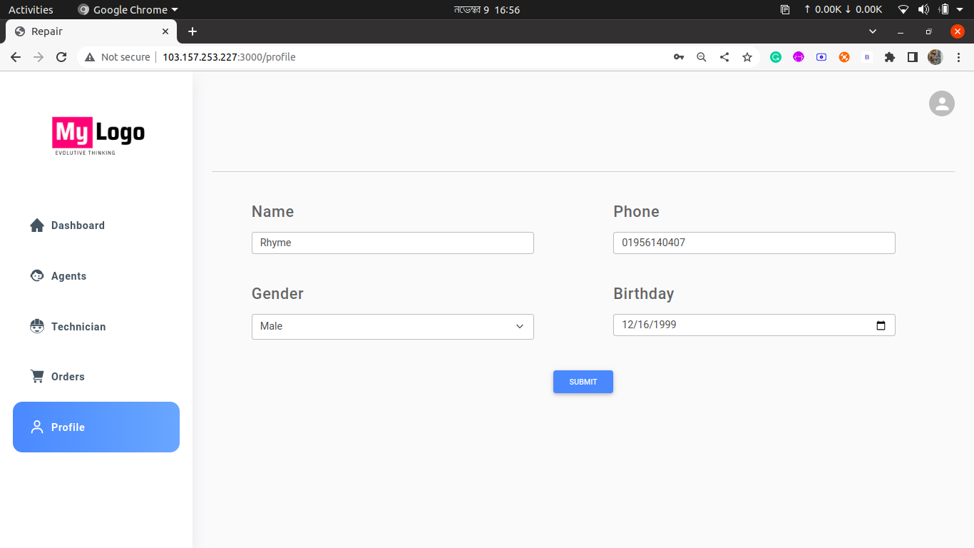

Figure 51: Profile Page

**4.2 Back End Design**

**Database**

We used NodeJS for user authentication for this project. For storage, we use MongoDB atlas NoSQL database [cloud database storage].

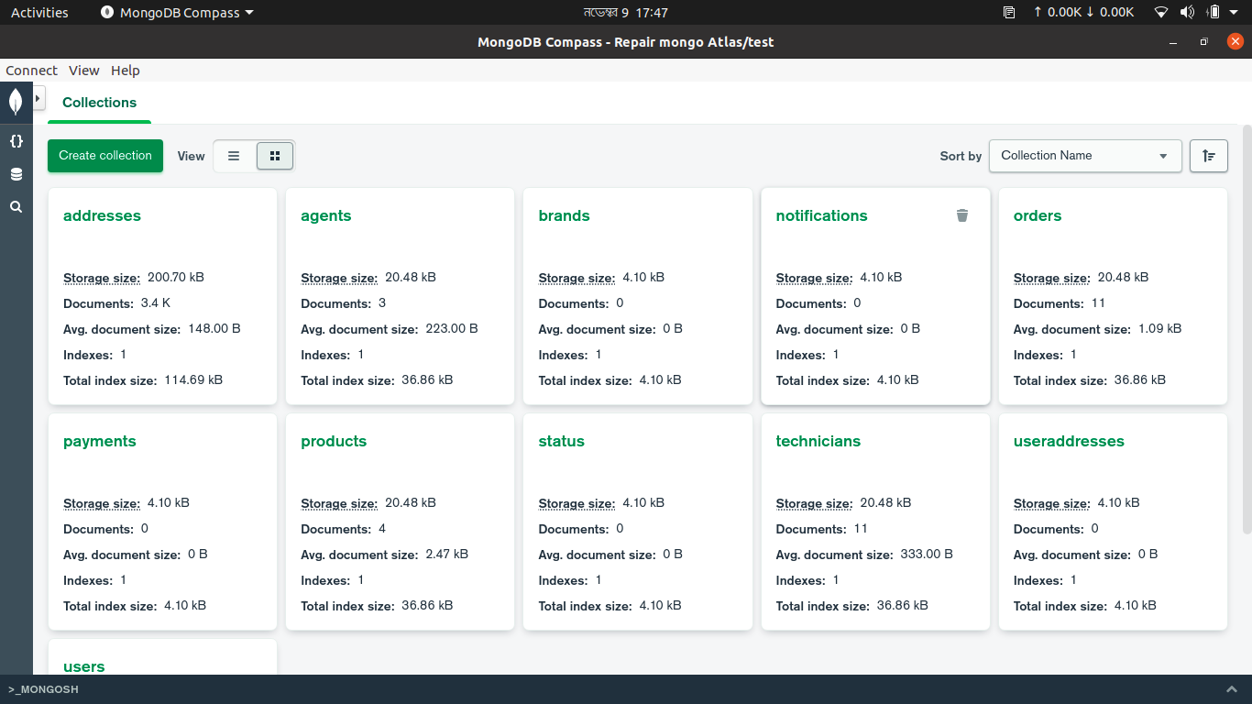

Figure 52: All Schema for database

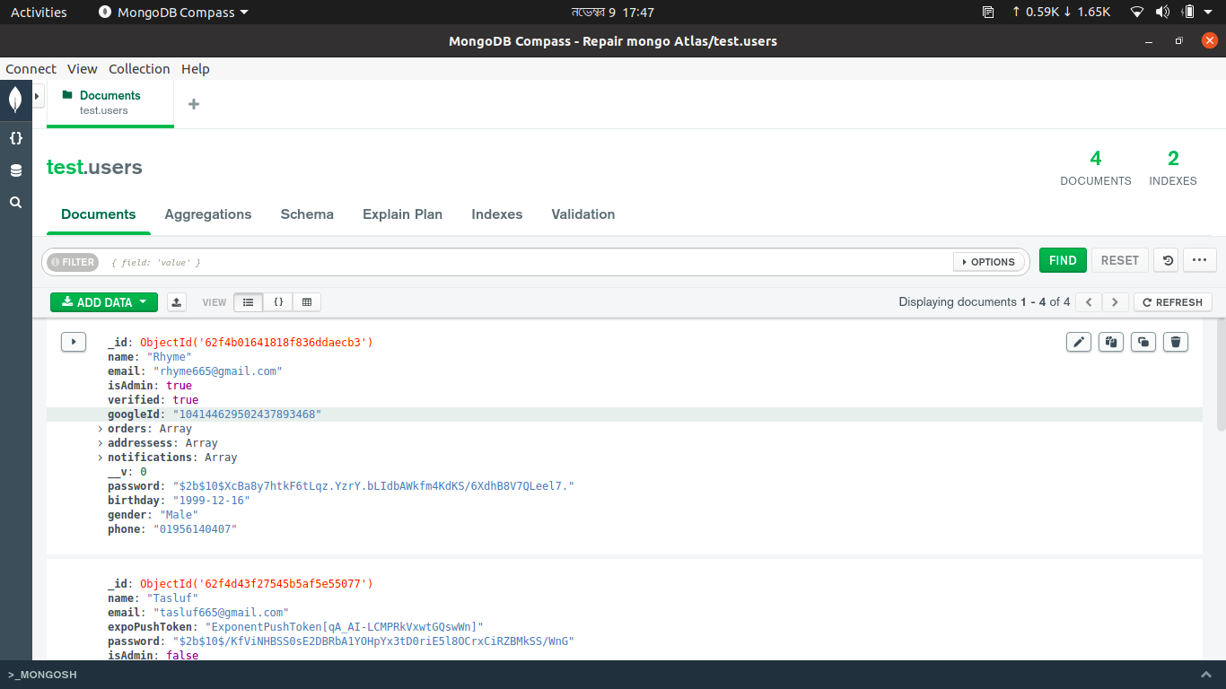

Figure 53: User Table

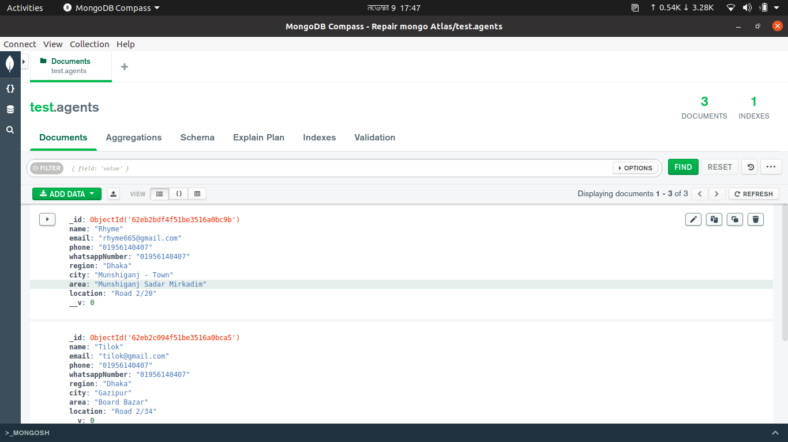

Figure 54: Agent Table

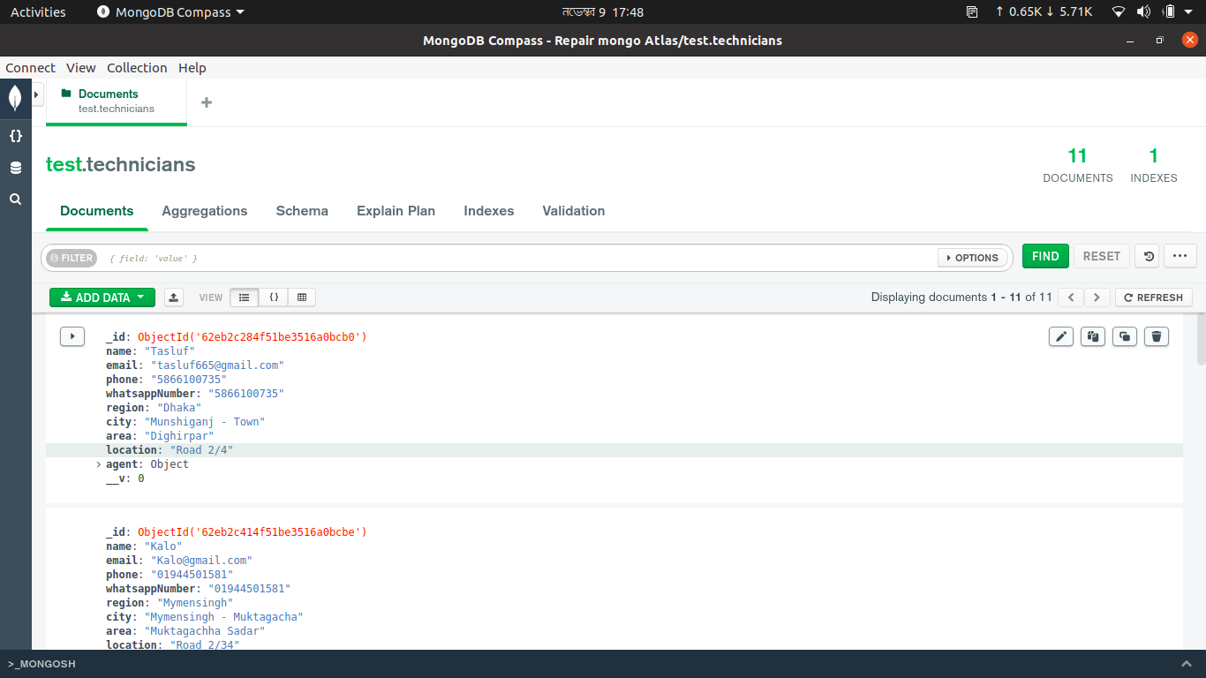

Figure 55: Technician Table

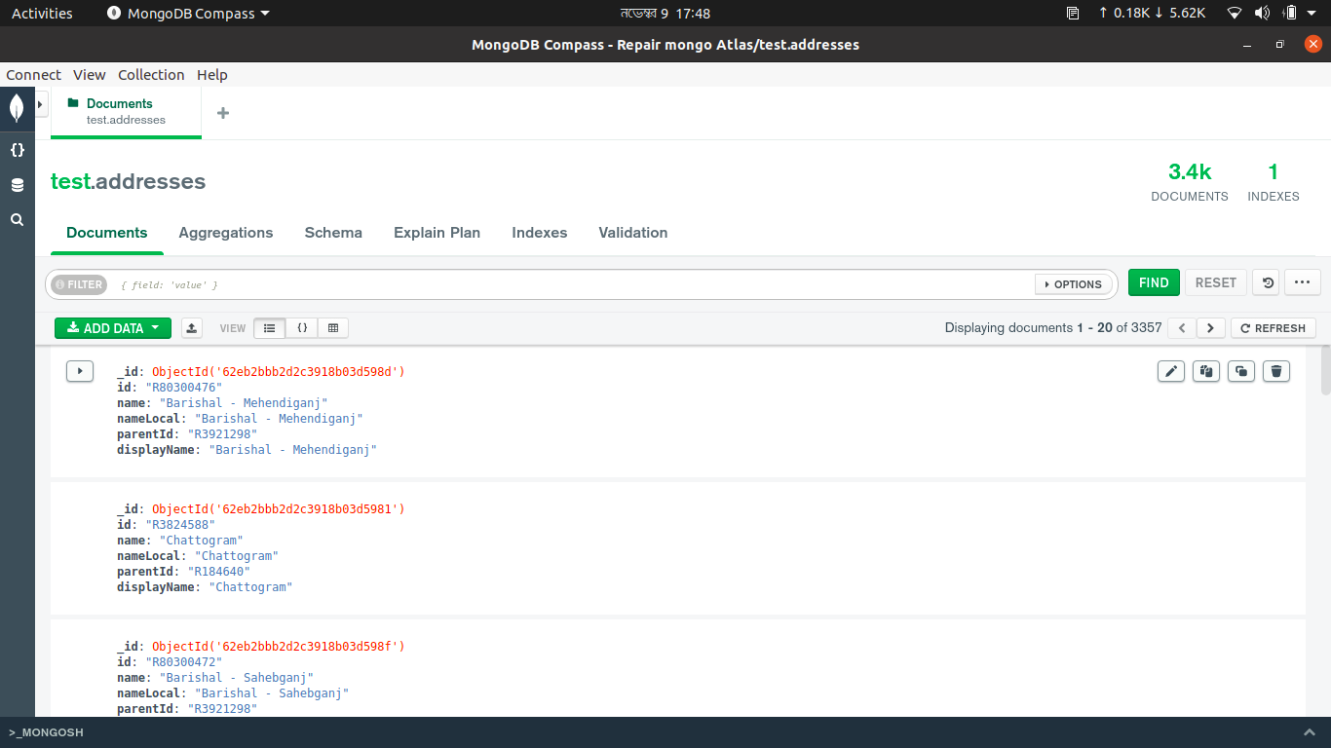

Figure 56: Address Table

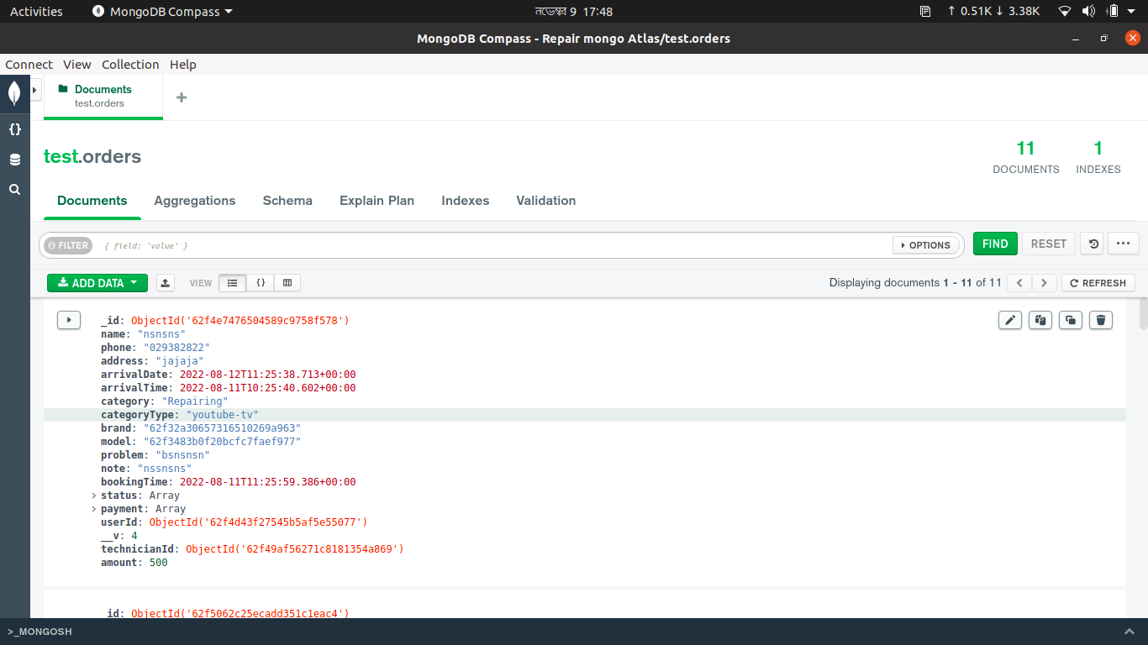

Figure 57: Orders Table

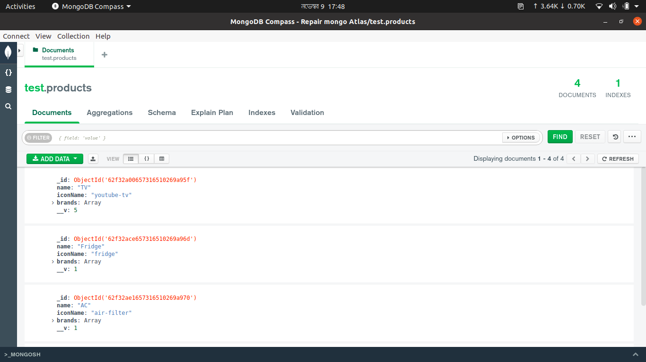

Figure 58: Products Table

**4.3 Interaction Design and User Experience (UX)**

I have used Figma [an online UX design application] for the initial design of our application. Then we implemented this design in our android app and admin panel. We use different React and React native libraries. And we also use Bootstrap for the design implementation. These elements represent our app well and make it affordable. By working with the user through this application, it is possible to get the satisfaction of the user in any business case. The user experience is getting better due to the process of enhancing stoner satisfaction with the app and pleasure handed in the commerce with the application.

**4.4 Implementation Requirement**

1. Figma for initial design
2. HTML, CSS and JavaScript
3. Bootstrap and Material UI for design implementation
4. React to make the admin panel.
5. React Native to implement the Android native application.
6. NodeJS for back-end implementation.
7. Express for Rest API
8. MongoDB for database

**CHAPTER 5**

**Implementation and Testing**

**5.1 Implementation of Database**

We have used MongoDB atlas for the database. It's a cloud NoSQL database. It's a secure and reliable database. First, our app will send requests to the back-end server. Then our server will authenticate the user and fetch data from the MongoDB database. Our NodeJS back-end app will make a connection with the cloud MongoDB database and whenever an authenticated user will request any data, it will send a response with that data. To make the connection we use Express and mongoose libraries for our back-end application.

**5.2 Implementation of Front-end Design**

For the Android Front-end part, we have used React-Native components like Text view, button, Card, View, etc. for the design part. We also use some popular libraries of React-Native. And for the Admin panel, we use React to make the component. We also use CSS, Material UI, Bootstrap, and other React libraries. We have divided the web page into smaller components and reused it every time whenever needed. Which makes our code reusable and easy to debug.

**5.3 Testing Implementation**

We implemented manual testing and automated testing for our application. By manual testing, users use our app and test different features of our app. We also define automate testing for several different test cases. This automated testing will automatically run every time before the application start. We have defined this automated testing for our Back-end part to secure our REST API endpoints. For the automated testing, we have used the JEST library in NodeJS**.**

**5.4 Test Results and Reports**

**5.4.1 Automated Testing**

|  |  |  |  |  |  |
| --- | --- | --- | --- | --- | --- |
| **Test Case** | **Test Input** | **Expected Outcome** | **Obtained Outcome** | **Pass/Fail** | **Tested On** |
| Login | Valid Email and Password | Successfully Login | Successfully Login | Pass | 10-11-22 |
| Login | Valid Email and Invalid Password | Get 400 Error | Get 400 Error | Pass | 10-11-22 |
| Login | Valid Email and no Password | Get 400 Error | Get 400 Error | Pass | 10-11-22 |
| Refresh-Token | Provide refresh-token | Get new token | Get new token | Pass | 10-11-22 |
| Refresh-Token | Provide no refresh-token | Get 401 Error | Get 401 Error | Pass | 10-11-22 |
| Address List | Provide Token | Get address List | Get address List | Pass | 10-11-22 |
| Address List | Provide No Token | Get 401 Error | Get 401 Error | Pass | 10-11-22 |
| Agents List | Provide Admin Token | Get Agents List | Get Agents List | Pass | 10-11-22 |
| Agents List | Provide User Token | Get 403 Error | Get 403 Error | Pass | 10-11-22 |
| Agents List | Provide No Token | Get 401 Error | Get 401 Error | Pass | 10-11-22 |
| Technician List | Provide admin Token | Get Technician List | Get Technician List | Pass | 10-11-22 |
| Technician List | Provide User Token | Get 403 Error | Get 403 Error | Pass | 10-11-22 |
| Technician List | Provide No Token | Get 401 Error | Get 401 Error | Pass | 10-11-22 |
| Order List | Provide admin Token | Get Order List | Get Order List | Pass | 10-11-22 |
| Order List | Provide User Token | Get 403 Error | Get 403 Error | Pass | 10-11-22 |
| Order List | Provide No Token | Get 401 Error | Get 401 Error | Pass | 10-11-22 |

Table 10: Automated Testing Result

**Coding example of Automated Test by JEST framework:**

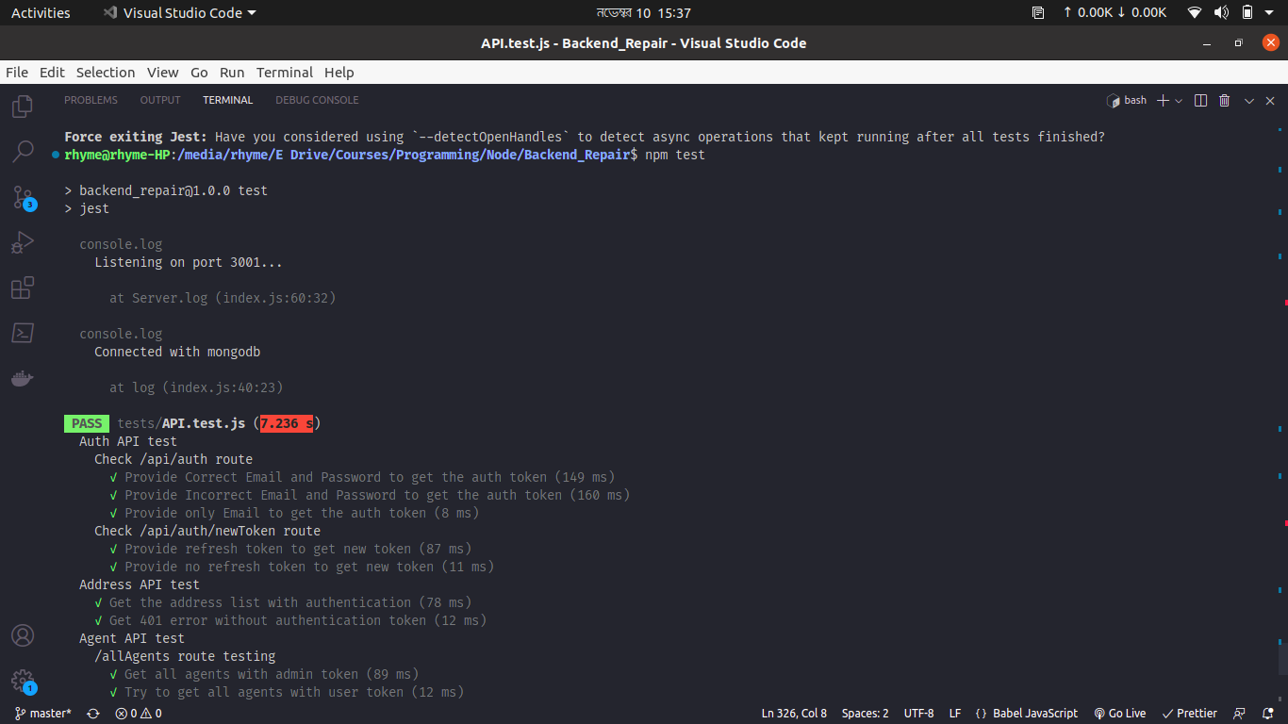

Figure 59: Automated Test figure 1

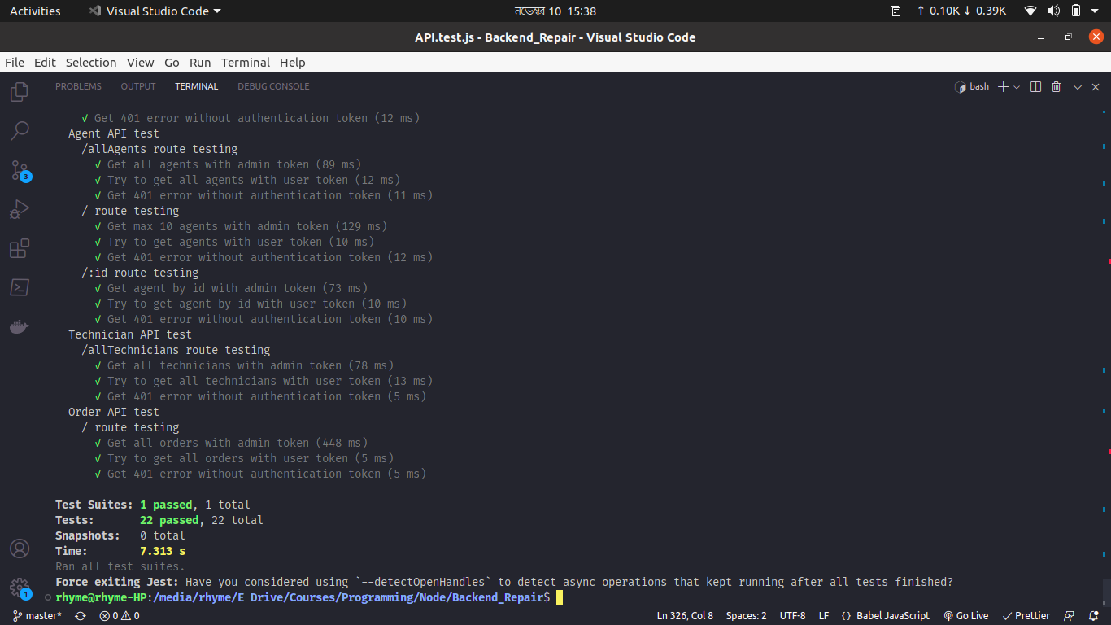

Figure 60: Automated Test figure 2

**CHAPTER 6**

**Impact on Society, Environment and Sustainability**

**6.1 Impact on Society**

Mobile app development is one of the fastest-growing areas of modern time. Now a days, it’s become an essential part of our daily lives, therefor it has a significant impact on our society. As people spend more hour on our portable device, we need to ensure that the apps we build are secure and reliable for them. Therefor the developer of this app will create a unique innovative and user friendly app. We offer a wide range of services, including servicing, booking, solidity, guaranty, customer care, cost saving facilities and much more.

We can say that “**Android Based Electronic Product Servicing System**” is a Mobile application as well web-based service system that is essential for any society. It will create an easier path for people to get an instant servicing solution. Professional expertise, strong logistics, transportation facilities could be the ultimate solution for a society. This project expect to reduce a lot of work load, by providing all this facilities for people that can create a positive impact on society.

**6.2 Impact on Environment**

In the 21th century while the world is developing based on indristrial revolution day by day, in that very time some factor are threating this positive growth. E-waste is considered as one of the major factor among them. E-waste refers to electronic products, that are unwanted, not working, or at the end of their life span, such as computers, televisions, VCRs, fax machines, motherboard, processor, RAM and other types of electronic products. The current global production of E-waste is estimated to be 20–25 million tons per year and the number increase quite sharply. Researcher expected it can doubled its size within next ten years. E-waste contains valuable metals as well potentially harmful materials such as lead, beryllium, cadmium, or brominated flame retardants. In our local market, whenever an Ac, TV, refrigerator, washing machine or oven are serviced by local technician, they didn’t follow the proper safety rules. Therefore, the harmful chemical that contain by this product, is released into the environment which cause damage to human blood, kidneys, as well as peripheral nervous systems. Burning E-waste may generate dioxins, furans, PAHs, PHAHs, and hydrogen chloride. This chemical are released into the air damaging the atmosphere. Most E-waste is thrown away in landfills their toxic materials seep into groundwater, affecting both land and sea animals. This can also affect the health of the people in consumption of this as food.

In this application whenever we register a vendor or work shop as a service provider, we will take all the details of their work policy in present. First we will make sure they followed all the safety rules based on human, environment and ecological balance. We will aware, teach and monitor them to prevent this threat which reduce E waste and contribute on a healthy environment.

**6.3 Ethical Aspects**

Ethical aspects refer to the moral philosophy that involves systematizing, defending, and recommending concept of right and wrong behavior of an application. Whenever a user install an apps or visit a website on his device it needs some excusable permission. Based on this permission, a site can get access to user personal data. By analyzing this data with the help of AI, it can determine characteristics of people most likely to engage in certain behavior. Then target the person to attract as new businesses consumers. It can compromise the confidentiality, integrity, availability, authenticity of user personal information. Some websites have security flaws which are unknown to its developer team. Attacker analyze this vulnerability and compromise system control in order to get unauthorized access to that system as a result potential data loss.

To make sure our customer security, before collecting any data we will informed about the data collection purpose and use policies of a business or organization, in details opt-out email form. Then they have the authority to decide whether or not to interact with that business or organization. Without snooping on any other information, we will ensure stronger protection of this sensitive data and keep this data only as long as needed. We will go through “3R” of ethics as rules, responsibility and respect. We will provide a specific guidelines for professional to perform their roles and how to conduct themselves when situation with professional practice. To secure from external threat we will go through a proper training and testing process. We will evaluate potential risk level and risk frequency in a scale of high, medium and low as well update incident handling process on a regular bases to prevent security threat and fulfill user requirements. Sometime service center charge as much money for a simple solution and people don’t have the idea what's going on. However in this apps service charge are fixed and updated in the website. That’s why they are bound in any unfair charges.

**6.4 Sustainability Plan**

The sustainability in this app we update my brand ethos. We will implement our very own service center to support the customer as well brand value. We will add sustainable electronic product selling because now it’s a prototype. We will reduce plastic packaging and use ecofriendly materials to support the eco system. Also, there will be a strict recycling policies. This app will reduce E-waste and energy waste. Most importantly we will create an offset service charge at checkout that will increase customer satisfaction and hold then with the app. Consider an ecommerce marketplace to sell we will be use merchandise business policy that will increase business opportunity and support sustainability of our application.

**CHAPTER 7**

**CONCLUSION AND FUTURE SCOPE**

**7.1 Discussion and Conclusion**

**“Android based electronic product servicing system”** is an application or site that provides an easier and unique business system. This smart and improving system helps to get any types of servicing effortlessly and make a stander business cycle, creating more business opportunity and local market won’t get disrupt. Moreover, it can be the best solution for vendors, service provider and customers everyone’s products by providing a necessary service based on there requirement also save time as well. It will develop the business supply chain and economy.

**7.2 Scope for Further Developments**

We plan to make something in future with this application.

Add new features and business

Electronic product buying

Expend service Centre

Expend in different cities

Establish company own service Centre.

Improve and update quality

Fix previous bug and incident handling method

Update UI design based on user requirement

Improve database and payment gateway.

**Reference**

[1] “Electronic Goods Repairing & Servicing in Bangladesh,” *www.bdtradeinfo.com*. https://www.bdtradeinfo.com/yp-data/electronic-goods-repairing-servicing.

[2] T. H. Phạm, “B2B Brand Management,” *www.academia.edu*, [Online]. Available: https://www.academia.edu/14558996/B2B_Brand_Management

‌

[3] StatCounter, “Mobile Operating System Market Share Worldwide,” *StatCounter Global Stats*, 2022. https://gs.statcounter.com/os-market-share/mobile/worldwide

‌

[4] “React Native Tutorial for Beginners - Build a React Native App,” *www.youtube.com*. https://www.youtube.com/watch?v=0-S5a0eXPoc.

‌

[5] “Consumer Electronics: Home Appliance Industry in Bangladesh,” *Business Inspection BD*, Mar. 04, 2022. https://businessinspection.com.bd/home-appliance-industry-in-bd/

[6] “Massive electrification sparked electrical goods industry,” *The Business Standard*, Dec. 10, 2021. https://www.tbsnews.net/economy/industry/massive-electrification-sparked-electrical-goods-industry-341755

[7] R. E. Anderson and S. S. Srinivasan, “E-satisfaction and e-loyalty: A contingency framework,” *Psychology and Marketing*, vol. 20, no. 2, pp. 123–138, Jan. 2003, doi: 10.1002/mar.10063.

‌

[8] “E-waste Management for Environmental Sustainability: an Exploratory Study,” *Procedia CIRP*, vol. 98, pp. 193–198, Jan. 2021, doi: 10.1016/j.procir.2021.01.029.

[9] R. E. &. S. S. S. Anderson, " E‐satisfaction and e‐loyalty: A contingency framework," Psychology

& marketing, 20(2), 123-138., 2003.

[10] M. A. Cusumano, “The Changing Software Business: Moving from Products to Services,” *Computer*, vol. 41, no. 1, pp. 20–27, Jan. 2008, doi: 10.1109/mc.2008.29.

[11] Y. M. K. C. &. F. S. Lu, Current standards landscape for smart manufacturing systems, National Institute of Standards and Technology, NISTIR, 8107, 3, 2016.

[12] M. Mohiuddin, Overview the e-commerce in Bangladesh, IOSR Journal of Business and Management, 16(7), 01-06., 2014.